ABSTRACT
The Anti-Ragging Management System is a web-based application designed to provide students with a structured method for reporting ragging incidents and to help authorised administrators review, investigate and update complaints. Ragging can be difficult to report when the process is unclear, inconvenient or hard to track, and informal reporting can leave records scattered and complaint progress invisible.
The application uses HTML, CSS and JavaScript for the user interface, PHP for server-side processing and MySQL for persistent storage. XAMPP provides a local development environment, while Visual Studio Code is used to edit the source files. The database anti_ragging contains the tables students, admins, complaints, complaint_status_history and notifications.
The application uses role-based access. Students can create accounts, submit incident details and view their own complaints. Administrators can review submissions, update status, enter remarks and maintain records. Password hashing, prepared statements, server-side validation and ownership checks support safer handling of sensitive information.
The project is an academic prototype. It does not independently verify allegations, make legal decisions or replace emergency assistance, and any real deployment would require institutional approval, secure configuration and formal procedures. The report follows the two modules and ten major sections of the TYCS index and demonstrates the practical application of software engineering, database management, web development and security principles.
TABLE OF CONTENTS
MODULE 1 v
1. Problem Identification & Feasibility Study 1
1.1 Identification of a Real-World Problem 1
1.2 Problem Justification 1
1.3 Scope Definition 2
1.4 Stakeholder Identification 2
1.5 Feasibility Study 3
1.5.1 Technical Feasibility 3
1.5.2 Economic Feasibility 3
1.5.3 Operational Feasibility 4
2. Requirement Engineering 5
2.1 Functional Requirements Specification 5
2.2 Non-Functional Requirements 6
2.3 Use-Case Analysis 6
2.4 Requirement Prioritization 7
2.5 Constraints and Assumptions 7
3. Software Development Life Cycle (SDLC) Planning 8
3.1 Selection of SDLC Model 8
3.2 Work Breakdown Structure (WBS) 9
3.3 Gantt Chart 9
3.4 Resource Planning 11
4. System Modeling Using UML 13
4.1 Use Case Diagram 13
4.2 Data Flow Diagram 14
4.3 Class Diagram 15
4.4 Sequence Diagram 16
4.5 Activity Diagram 17
4.6 Entity Relationship (ER) Diagram 18
4.7 Deployment Diagram 19
5. System Architecture Design 20
5.1 Frontend Architecture 20
5.2 Backend Architecture 21
5.3 Database Schema Design 21
5.4 Security Considerations 22
MODULE 2 24
6. Application Development 25
6.1 Frontend Implementation 25
6.2 Backend Implementation 29
6.3 Database Integration 31
6.4 Authentication and Validation 31
6.5 Error Handling 32
7. Integration & System Testing 34
7.1 Unit Testing 34
7.2 Black-Box Testing 34
7.3 Integration Testing 35
7.4 Test Case Preparation 35
7.5 Bug Tracking 36
8. Application Deployment 37
8.1 Cloud Deployment 37
8.2 Local Hosting 37
8.3 APK Build 37
8.4 Server Configuration 38
8.5 Version Control Using GitHub 38
9. Performance & Security Testing 39
9.1 Basic Load Testing 39
9.2 Input Validation Checks 39
9.3 Security Validation 39
10. Final Documentation 41
10.1 Report Generation 41
10.2 User Manual 41
10.3 Limitations 42
10.4 Future Enhancements 42
10.5 References 43
Conclusion 44
➢ Appendix A: Student User Manual 45
➢ Appendix B: Administrator User Manual 46
➢ Appendix C: Database Data Dictionary 47
➢ Appendix D: Acceptance Checklist 48
➢ Appendix E: Glossary 49
PROJECT OBJECTIVES AND MOTIVATION
The overall objective is to create a structured digital workflow for student complaint submission and administrative management. The motivation is to reduce confusion in reporting and tracking incidents by giving students and administrators a common digital process.

Project objectives
- Provide a clear digital reporting form.
- Support authenticated student access.
- Store complaints in a relational database.
- Enable authorised status updates.
- Improve record organisation and tracking.

Project motivation
- Promote awareness of the reporting workflow.
- Reduce dependence on scattered informal records.
- Provide status visibility to the student who reported the incident.
- Support consistent documentation.
- Maintain confidentiality through appropriate controls.

Existing system and proposed system
The comparison below is a general analysis of possible workflows. Actual practices vary by institution and are not described as universal facts.
Table: Existing and Proposed Workflow
Aspect | Existing Informal Workflow | Proposed System
Reporting | Paper, email or direct communication | Structured online form with required fields
Records | Scattered across files and messages | Centralised relational database
Visibility | Student may not know the progress | Student can view the status of own complaint
Review | Manual searching | Authorised staff review from a common dashboard
Control | Depends on individuals | Role-based access and ownership checks

Digitalisation does not automatically guarantee faster resolution or anonymity; those depend on policy and operation.
MODULE 1
Problem Identification, Requirement Engineering & System Design Phase

1. Problem Identification & Feasibility Study
This chapter introduces the real-world problem addressed by the Anti-Ragging Management System. It explains why the problem matters, defines the boundaries of the solution, identifies the people affected by the system and evaluates whether the project can be built successfully using the technical, economic and operational resources available.

1.1 Identification of a Real-World Problem
Students may find it difficult to report incidents when the process is unclear, inconvenient or difficult to track. Paper-based or informal reporting can result in scattered records, repeated follow-ups and limited visibility into complaint progress. A student who has experienced or witnessed an incident may hesitate when it is not clear whom to approach, what information to provide or whether the matter is being looked at.
Administrators and committee members face a related problem. When complaints arrive through different channels, it is hard to keep one reliable list, to know which case has been reviewed and to show what action was taken. Important details can be lost, and the same information may have to be requested again.
The central problem is therefore the lack of a clear, documented and controlled workflow that enables students to submit concerns and authorised personnel to review them. The Anti-Ragging Management System addresses this by providing a defined reporting form, centralised records and status tracking.

Common difficulties
- Unclear process: students do not know what to submit or where.
- Scattered records: complaints are spread across paper files and messages.
- Limited visibility: the reporting student cannot see progress.
- Repeated follow-ups: staff and students ask for the same information repeatedly.
- Weak accountability: actions taken on a complaint are not recorded consistently.
- Privacy risk: sensitive details can be seen by people without a legitimate role.

1.2 Problem Justification
The problem is not merely the absence of a website. It is the need for a clear, documented and controlled workflow that enables students to submit concerns and authorised personnel to review them. A software tool can improve organisation, but it cannot by itself guarantee safety or institutional action. Its value lies in making the reporting steps clear and the records easier to manage.
Table 1.1: Needs and System Responses
Need | How the System Responds
Clear submission instructions | A structured form states the information required
A queue of complaints for staff | Administrator dashboard lists submitted complaints
Certainty about progress | Case status is stored and shown to the owner
No lost information | Centralised database records
Restricted access | Role checks and ownership checks on protected pages

The project is also appropriate as an academic mini project because it combines forms, authentication, role-based authorisation, relational design, validation and security, which are core topics of the course.

1.3 Scope Definition
The prototype includes student registration and login, complaint submission, complaint history, administrator login, complaint review, status updates, remarks, student records and basic reports. It does not independently verify allegations, make legal decisions or replace emergency assistance. A clear scope prevents unrealistic expectations and helps the evaluator understand the intended boundaries of the system.

Included in the scope
- Student account creation and authentication.
- Structured complaint data and status tracking.
- Administrator review and status management.
- Remarks and status history where implemented.
- Basic complaint summaries and reports.

Not guaranteed by the system
- Automated legal decisions or automatic guilt determination.
- Independent verification of allegations.
- SMS, email alerts and a mobile APK unless separately implemented.
- Emergency response; urgent risks must follow institutional procedures.
Table 1.2: In-Scope and Out-of-Scope Items
In Scope | Out of Scope
Registration, login, complaint submission | Legal decisions and guilt determination
Complaint history and status tracking | Emergency assistance
Administrator review, status and remarks | SMS / email alerts unless implemented
Basic reports | Native mobile application

1.4 Stakeholder Identification
Stakeholder analysis identifies the people who interact with the application or are affected by its operation. The design reflects both direct users and the institution responsible for policy and case handling.
Table 1.3: Stakeholders of the Anti-Ragging Management System
Stakeholder | Role | Expectation
Student | Submits complaints and tracks own records | Simple, safe and understandable process
Administrator | Reviews complaints and records actions | Reliable queue, status control and records
Project guide / department | Evaluates the academic deliverable | Correct engineering process and documentation
Institutional authorities | Define escalation and retention procedures | Policy-compliant handling
Technical maintainers | Configure, back up and update the system | Maintainable, documented setup

1.5 Feasibility Study
Feasibility considers whether the application can be built with available technology, whether costs are reasonable and whether the workflow can be used operationally. The project is suitable as a local academic prototype using common web technologies. Risks include database configuration, access control, upload safety and maintenance, and production use would require hosting, backups, HTTPS and institutional approval.

1.5.1 Technical Feasibility
The system uses a standard client-server pattern. The browser displays the user interface, PHP processes requests and the relational database stores records. XAMPP provides Apache and a MySQL-compatible database service for local testing. PHP handles sessions, validation and database operations, and MySQL stores accounts, complaints, status history and notifications. The database port and credentials must match the actual XAMPP configuration.
Table 1.4: Technology Stack and Purpose
Technology | Purpose
HTML | Page structure
CSS | Layout and responsive styling
JavaScript | Client-side interaction
PHP | Sessions, validation, business rules and database access
MySQL / MariaDB | Persistent relational records
XAMPP | Local Apache and database services
Visual Studio Code | Source editor

1.5.2 Economic Feasibility
The academic prototype can be built with open-source or freely available tools, and local testing does not require paid hosting. Costs may arise if the institution later chooses a domain, cloud hosting, monitoring, backups, a security assessment or staff training. A formal budget should be prepared before production deployment.
Table 1.5: Cost Estimate
Item | Cost Category | Remarks
Development tools | No compulsory licence cost | Chosen stack is freely available
Hardware | Existing laptop or desktop | No new purchase required
Hosting, domain, backups | Operational cost if deployed | Not needed for local demonstration
Training | Limited for a prototype | Needed for staff in practice

1.5.3 Operational Feasibility
The system should be understandable to students and authorised staff. Forms need clear labels, helpful validation and consistent status terms. Operational success depends on trained personnel, timely review, escalation rules and procedures for sensitive information. The institution must define how urgent cases are escalated, and the system must not be treated as a substitute for emergency assistance.
The feasibility study therefore concludes that the Anti-Ragging Management System is technically, economically and operationally viable as an academic prototype and that the project should proceed to requirement engineering.

2. Requirement Engineering
Requirement engineering translates the problem statement into verifiable expectations. It defines what the system must do, what quality constraints apply and how the completed work can be tested. This chapter lists the functional and non-functional requirements, analyses the use cases, prioritises the requirements and records the constraints and assumptions.

2.1 Functional Requirements Specification
The following functional requirements describe the intended core workflow. Each requirement should be checked against the final code before submission.
Table 2.1: Functional Requirements
ID | Functional Requirement | Priority
FR-01 | Student can register using required details | High
FR-02 | Duplicate email or roll number is rejected | High
FR-03 | Registered student can log in with valid credentials | High
FR-04 | Student can submit a complaint with incident details | High
FR-05 | Required fields are validated on the server | High
FR-06 | Student can view only their own complaint records | High
FR-07 | Authorised administrator can log in | High
FR-08 | Administrator can review and update complaint status | High
FR-09 | Remarks and status history can be stored where implemented | Medium
FR-10 | Basic complaint summaries and reports can be displayed | Medium

Table 2.2: Detailed Description of Key Requirements
ID | Detailed Description
FR-01 / FR-02 | Name, email, course, roll number and password are validated. The password is hashed with password_hash(). Duplicate email addresses or roll numbers are rejected.
FR-03 | Credentials are checked with password_verify(); a session is created only on success and the session ID is regenerated.
FR-04 / FR-05 | The complaint form requires a title and incident details; fields are validated on the server before an insert. The owner is taken from the session.
FR-06 | All complaint queries for students are filtered by the logged-in student’s identifier.
FR-08 / FR-09 | The administrator chooses a valid status and may add remarks; the change is saved and a history record can be created.

2.2 Non-Functional Requirements
Non-functional requirements define quality expectations for the application. They are assessed through review and testing rather than assumed to be satisfied merely because a page exists.
Table 2.3: Non-Functional Requirements
Attribute | Requirement
Security | Passwords are hashed and SQL values are parameterised
Privacy | Records are available only to authorised roles
Usability | Forms are readable and give useful validation messages
Reliability | Valid submissions persist and errors are handled clearly
Maintainability | Source files use a logical folder structure
Compatibility | Pages work in modern browsers and adapt to mobile screens
Auditability | Important status changes are recorded when implemented

2.3 Use-Case Analysis
The primary actors are the Student and the Administrator. A student registers, signs in, submits a complaint, views history and checks status. An administrator signs in, reviews complaints, changes status, records remarks and reviews permitted reports. Supporting use cases are validating input, storing data and recording status history. Unauthorised users must not access protected pages, and the model is updated if the final implementation adds or removes a feature.
Table 2.4: Actors and Their Use Cases
Actor | Use Cases
Student | Register, log in, submit complaint, view own complaints, track status, log out
Administrator | Log in, view complaints, inspect details, update status, add remarks, view reports

Table 2.5: Use Case Specification – Submit Complaint
Item | Description
Actor | Authenticated Student
Precondition | Student is logged in
Input | Complaint title, incident details and any other required fields
Main Flow | Open form → submit → validate → save complaint → optional notification → confirmation
Alternative Flow | Missing field → validation errors and the form is shown again
Exception Flow | Database failure → controlled error message; no success is shown
Postcondition | Complaint is stored with the student identifier

2.4 Requirement Prioritization
Prioritisation helps the project focus on essential capabilities before optional enhancements.
Table 2.6: Requirement Priorities
Priority | Items
Must have | Registration, login, complaint submission and database storage; ownership checks and complaint status display
Should have | Admin dashboard, filters, remarks and basic reporting
Could have | Notification history, evidence uploads and richer analytics
Future | Multi-factor admin authentication, email alerts and audit reports

2.5 Constraints and Assumptions

Constraints
- The system depends on correct database connection settings.
- A local application is not accessible from another network by default.
- Complaint information is sensitive and must not be used as sample public data.
- Institutional policy and applicable law govern real case handling.
- The project must be completed within the academic schedule.

Assumptions
- Administrators are created through a controlled setup process.
- Users provide accurate information.
- Test data are synthetic.
- The user has a modern browser.

3. Software Development Life Cycle (SDLC) Planning
An iterative SDLC approach is suitable for a mini project because the developer can build a small working feature, test it and then add the next module. This makes database and authentication problems easier to isolate. This chapter explains the selection of the SDLC model, the work breakdown, the schedule and the resources required.

3.1 Selection of SDLC Model
The iterative model supports gradual development and review. Requirements are identified early, but small adjustments can be made after testing. It is appropriate for a student project where features may need refinement as the interface and database are tested. Testing occurs after each module, not only at the end, and a stable backup or version-control commit precedes major changes.
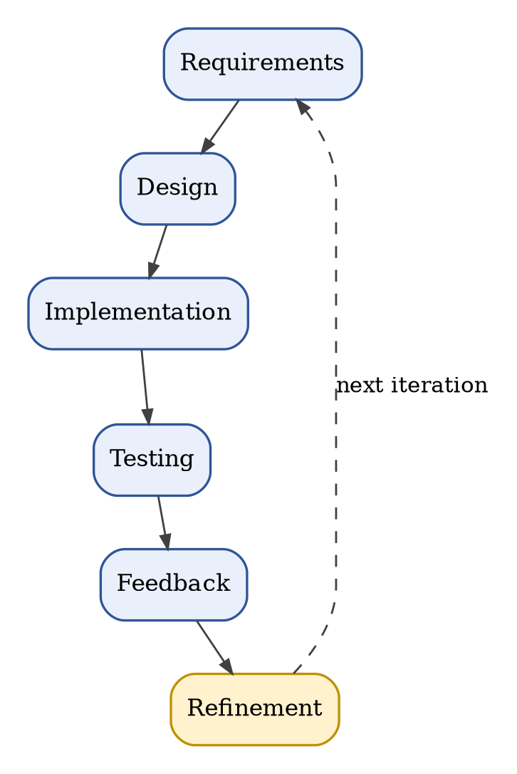
Figure 3.1: Iterative SDLC for the Anti-Ragging Management System
Table 3.1: Iteration Plan
Iteration | Work
1 | Scope, requirements and database plan
2 | Registration, login and session checks
3 | Complaint submission and student complaint list
4 | Admin dashboard and status management
5 | Testing, documentation and corrections

Table 3.2: Advantages and Limitations of the Iterative Model
Advantages | Limitations
Early working versions and regular feedback | Changes need control to avoid inconsistent documentation
Easier to locate defects within a small increment | Documentation must be updated after every iteration

3.2 Work Breakdown Structure (WBS)
The WBS divides the project into manageable tasks so that progress can be monitored and missing work identified.
Table 3.3: Work Breakdown Structure
ID | Work Package | Output
1 | Initiation | Title, problem statement, scope and objectives
2 | Analysis | Stakeholder needs and requirements
3 | Design | Architecture, database schema and UML models
4 | Interface | Homepage, registration, login and dashboards
5 | Backend | Sessions, validation and complaint operations
6 | Integration | Database connection and related table writes
7 | Testing | Unit, black-box, integration and security checks
8 | Deployment | Local configuration and optional hosting
9 | Documentation | Black book, user manual and references

3.3 Gantt Chart
The following is an illustrative six-week schedule. It is replaced with actual dates if required by the department, and it represents planning rather than evidence that each activity has already been completed. Resource planning is given in the next section.
Gantt Chart

Table 3.4: Project Schedule Summary
Activity | W1 | W2 | W3 | W4 | W5 | W6
Requirements | X | X
Design |  | X | X
Implementation |  |  | X | X | X
Testing |  |  |  | X | X | X
Documentation |  |  |  |  | X | X

Table 3.5: Weekly Plan
Week | Planned Work
Week 1 | Identify problem, stakeholders and requirements
Week 2 | Prepare database design and UML models
Week 3 | Develop the interface and authentication
Week 4 | Implement complaint submission and admin operations
Week 5 | Integrate, test and fix defects
Week 6 | Prepare final report, screenshots and demonstration

3.4 Resource Planning
The development environment is intentionally modest for a student mini project.
Table 3.6: Hardware and Software Requirements
Resource | Details
Hardware | Laptop or desktop, keyboard, mouse and sufficient storage
Operating system | Windows or another supported environment
Server stack | XAMPP with Apache and MySQL/MariaDB
Editor | Visual Studio Code
Browser | A modern browser such as Chrome or Edge
Languages | HTML, CSS, JavaScript, PHP and SQL
Human | Student developer and project guide

Project risks and mitigation
Table 3.7: Risks and Mitigation
Risk | Mitigation
Database corruption | Export backups before destructive changes
Port conflicts | Inspect service logs and actual port usage
Unauthorised access | Enforce role checks on protected pages
Invalid uploads | Validate type, size and storage location
Scope creep | Prioritise essential requirements first
Misleading documentation | Verify claims against delivered code

4. System Modeling Using UML
System models represent the application’s structure and behaviour. They help explain how students, administrators, PHP pages and database tables interact. The use-case diagram shows actors and system functions, the data flow diagram shows movement of data, the class diagram shows conceptual entities, the sequence and activity diagrams show behaviour, the ER diagram shows database entities and relationships and the deployment diagram shows the browser, web server and database.

4.1 Use Case Diagram
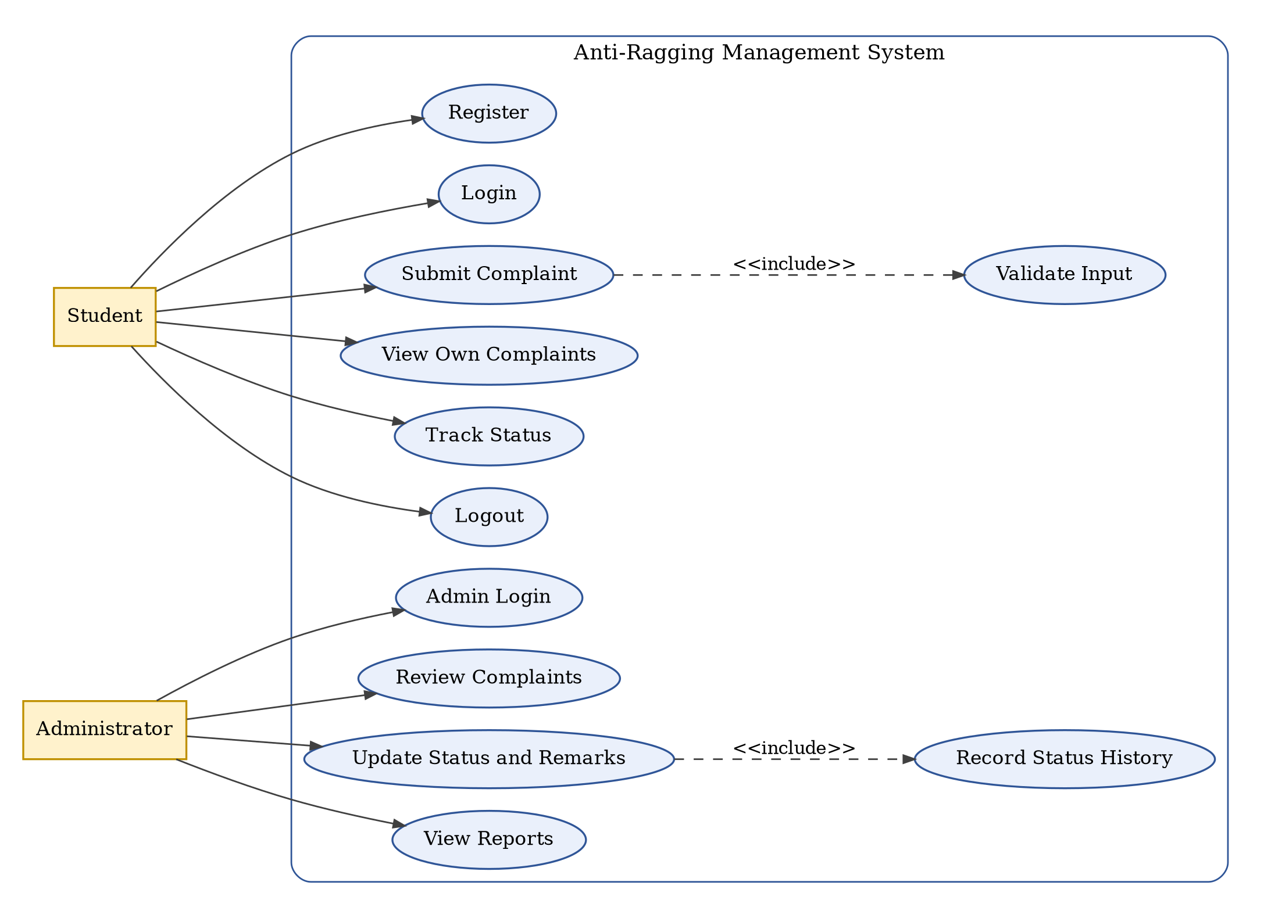
Figure 4.1: Anti-Ragging Management System Use Case Diagram

4.2 Data Flow Diagram
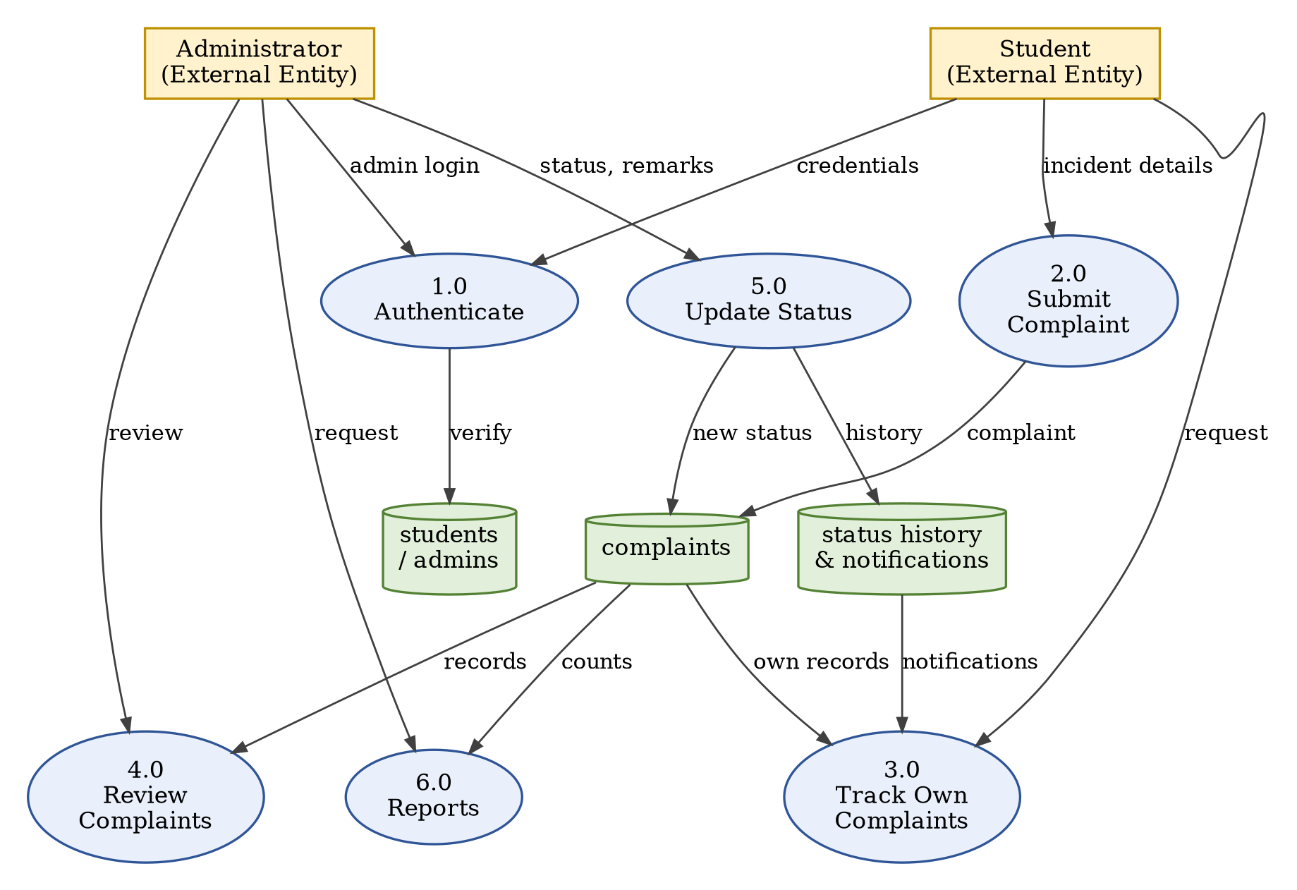
Figure 4.2: Anti-Ragging Management System Data Flow Diagram (Level 1)

4.3 Class Diagram
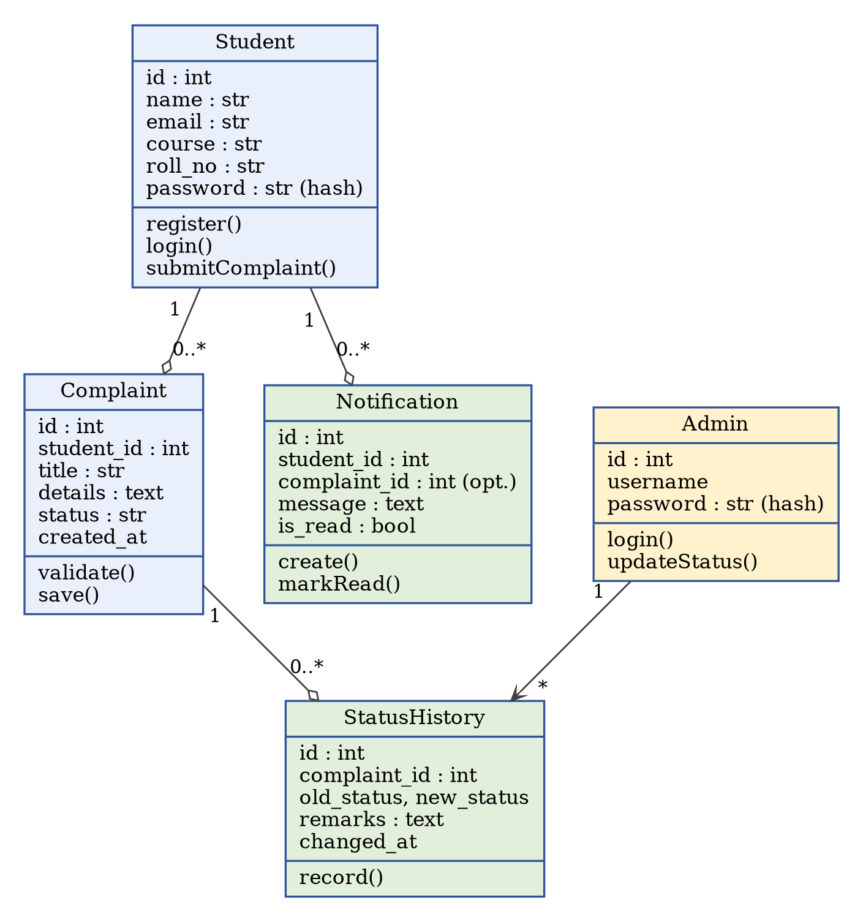
Figure 4.3: Conceptual Classes of the Anti-Ragging Management System

4.4 Sequence Diagram
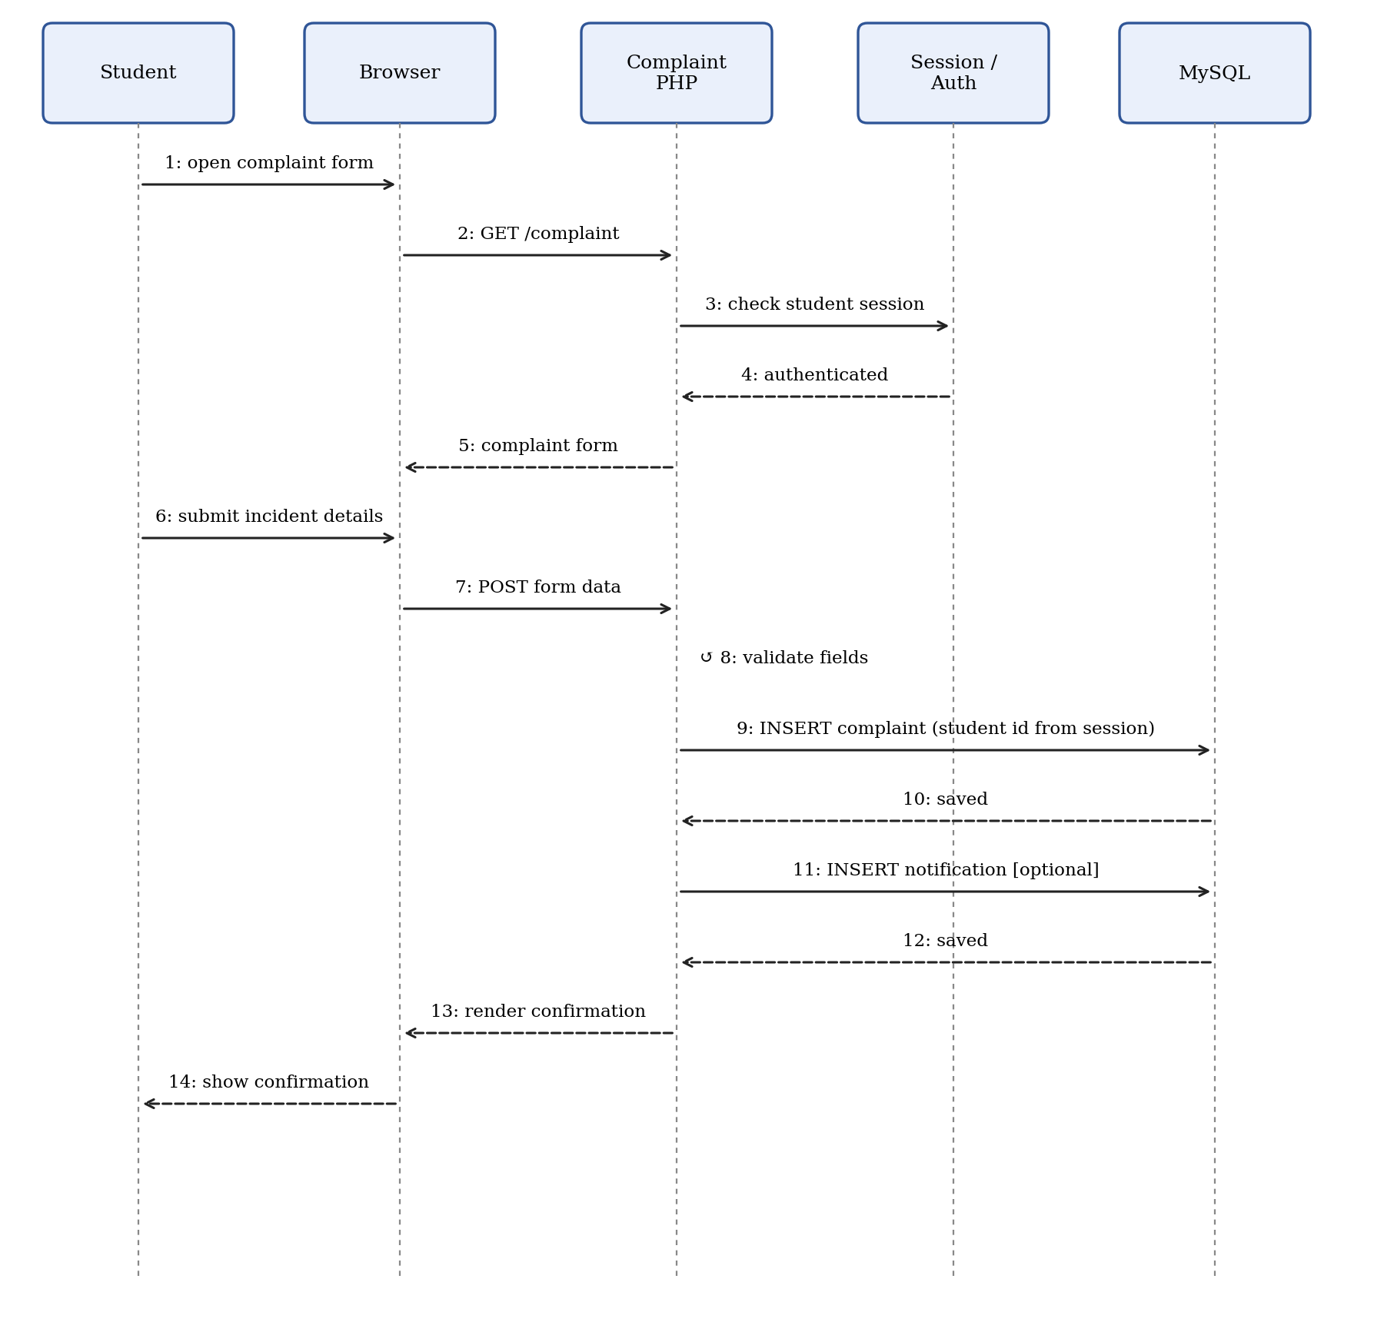
Figure 4.4: Complaint Submission Sequence Diagram

4.5 Activity Diagram
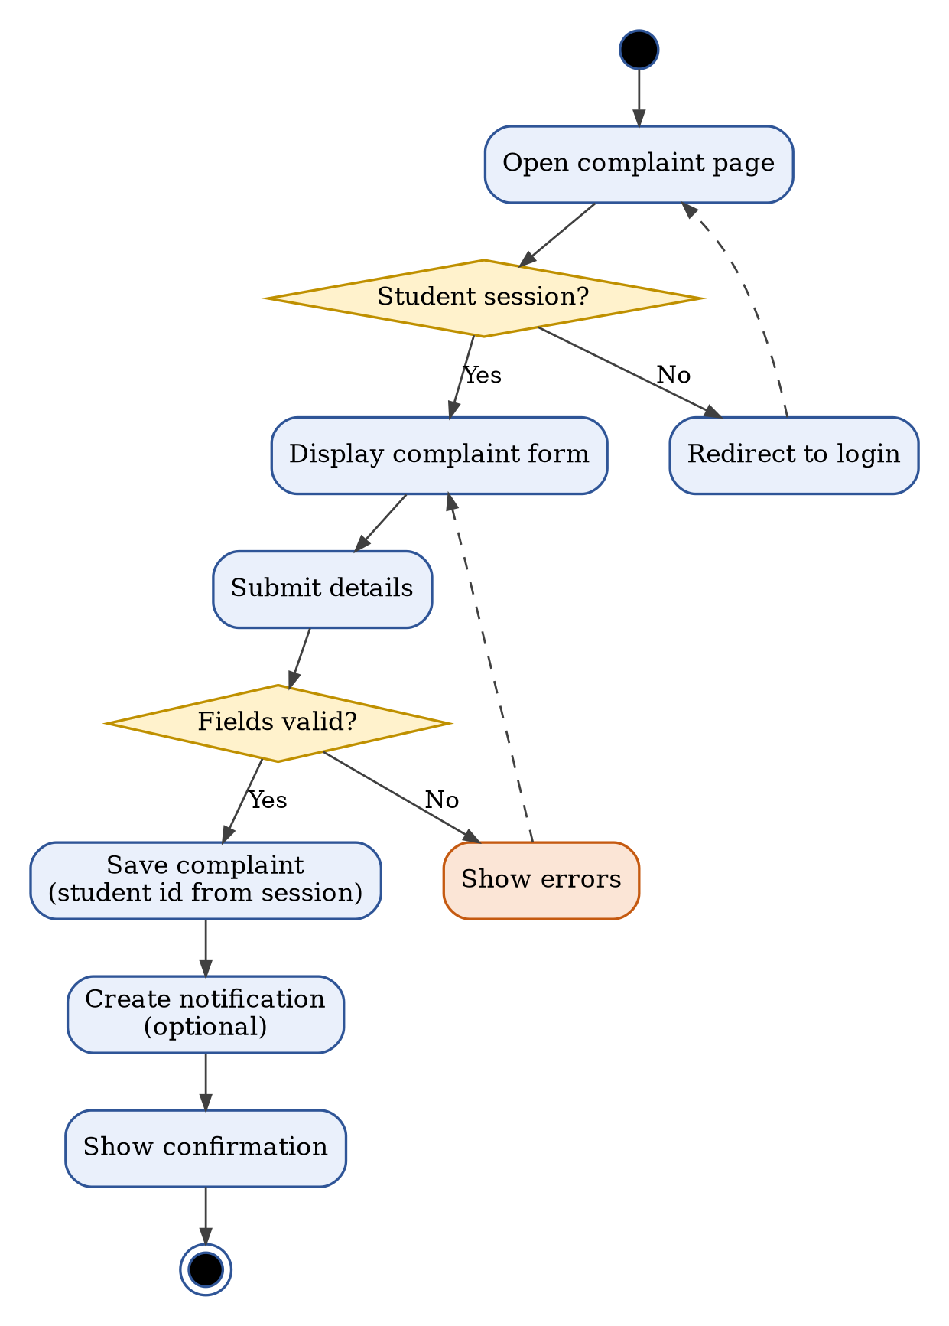
Figure 4.5: Complaint Submission Activity Diagram

4.6 Entity Relationship (ER) Diagram
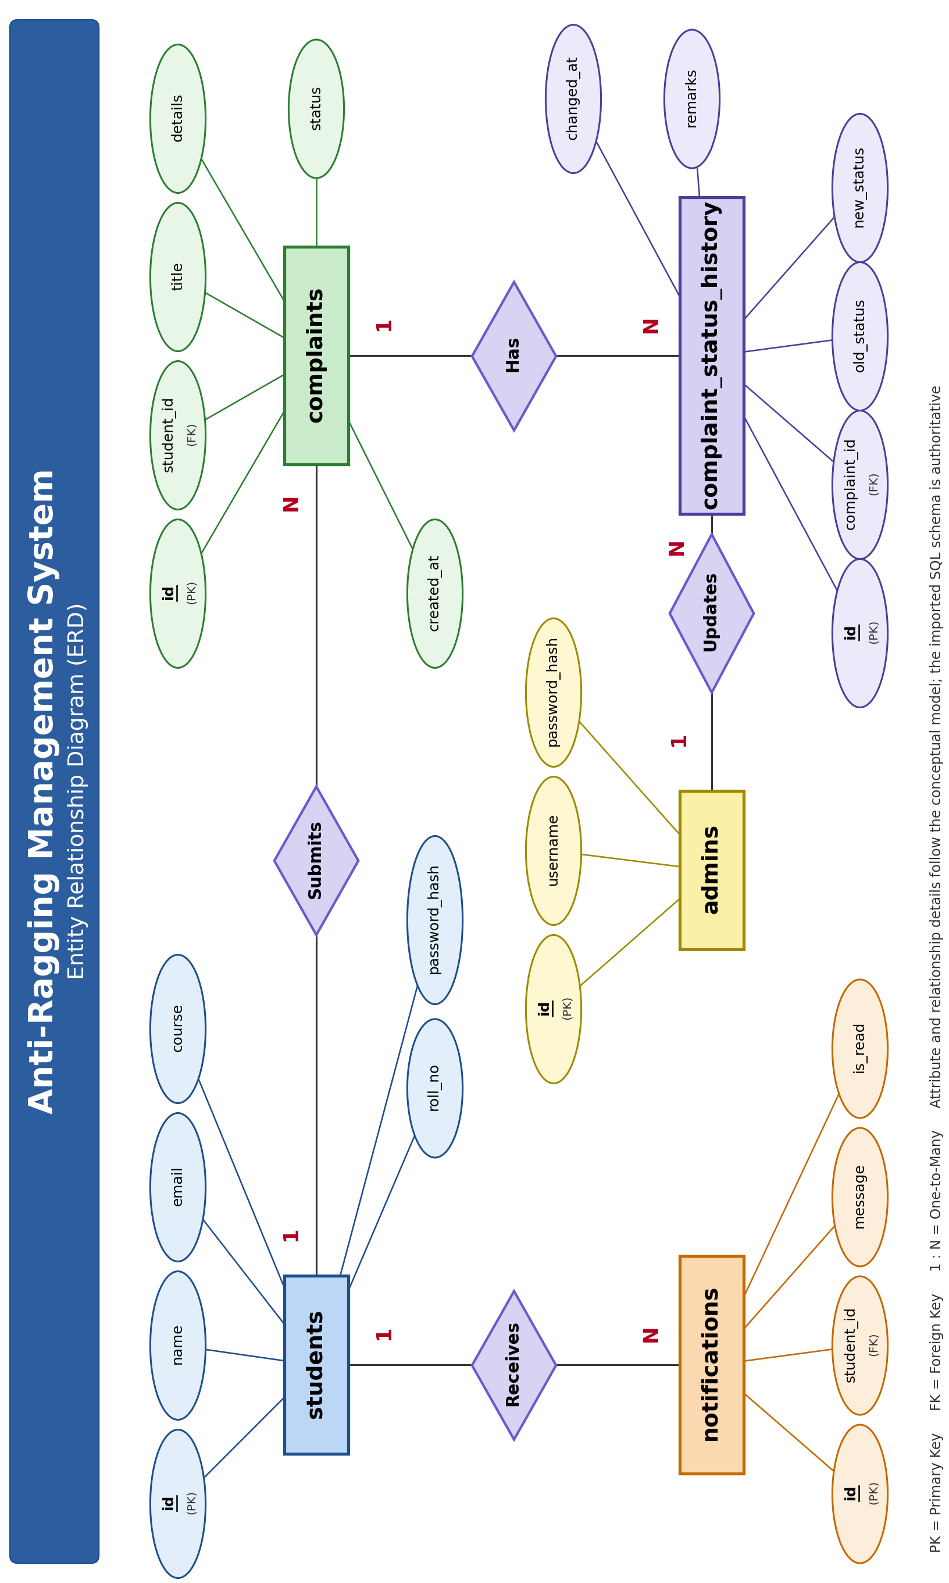
Figure 4.6: Anti-Ragging Management System ER Diagram

4.7 Deployment Diagram
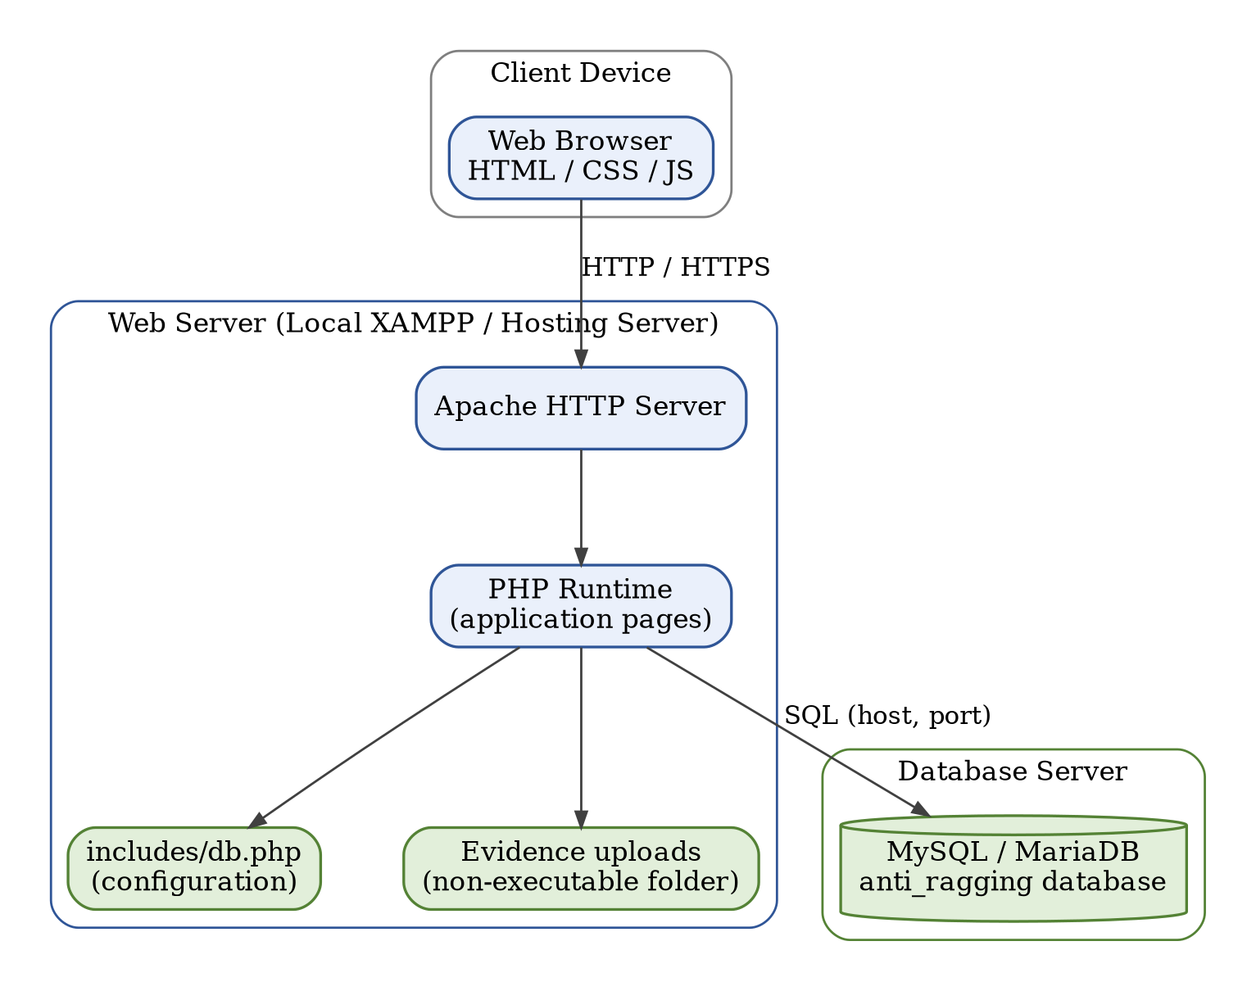
Figure 4.7: Anti-Ragging Management System Deployment Diagram

5. System Architecture Design
The system follows a three-layer architecture: presentation, application processing and data storage. Separating responsibilities improves maintainability and helps locate defects. Shared include files may centralise database and access-control logic, and protected pages must check role permissions on every request.
Table 5.1: Architecture Layers
Layer | Responsibility | Technology
Presentation | Forms and responsive pages | HTML / CSS / JavaScript
Application | Validation and business rules | PHP
Data | Persistent records | MySQL / MariaDB

5.1 Frontend Architecture
The frontend provides the visible experience for students and administrators. It uses consistent navigation, accessible labels, readable text and responsive layouts. Client-side validation is helpful but cannot replace server-side validation.
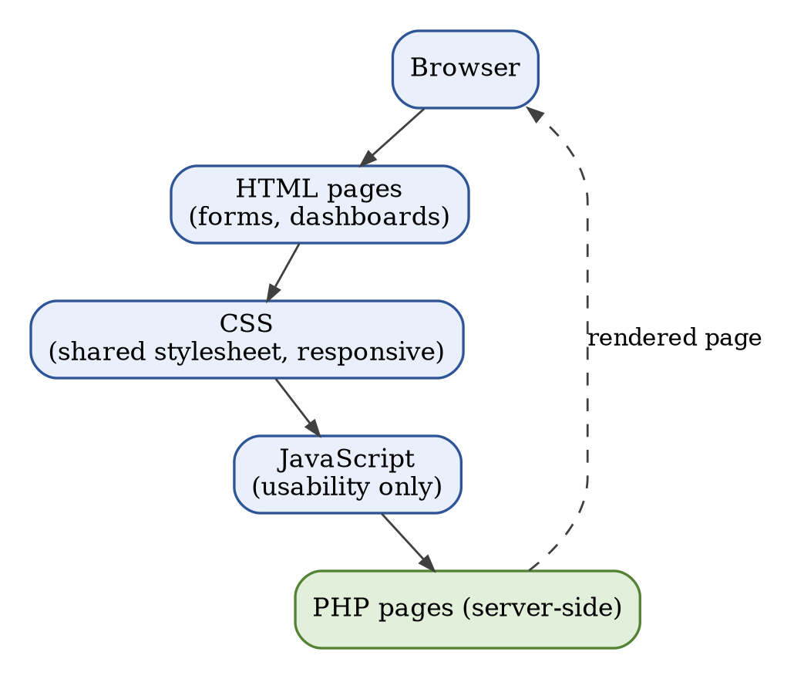
Figure 5.1: Frontend Architecture
Table 5.2: Main Frontend Pages
Page | Purpose
Homepage | Explains the system and links to account actions
Registration | Collects required student information
Login | Provides authentication feedback
Student dashboard | Summarises the user’s own complaints
Complaint form | Collects incident details
Complaint list / details | Shows own complaints and their status
Admin dashboard | Authorised case-management actions

5.2 Backend Architecture
PHP handles requests and applies the business rules. It verifies sessions, validates fields, executes parameterised SQL and returns a response. Role checks are implemented on the server rather than relying on hidden links. The database connection is configured in a shared include file, authentication uses password_hash() and password_verify(), prepared statements protect SQL queries that use user values, and ownership checks constrain students to their own records. Admin actions validate the new status and record the change.
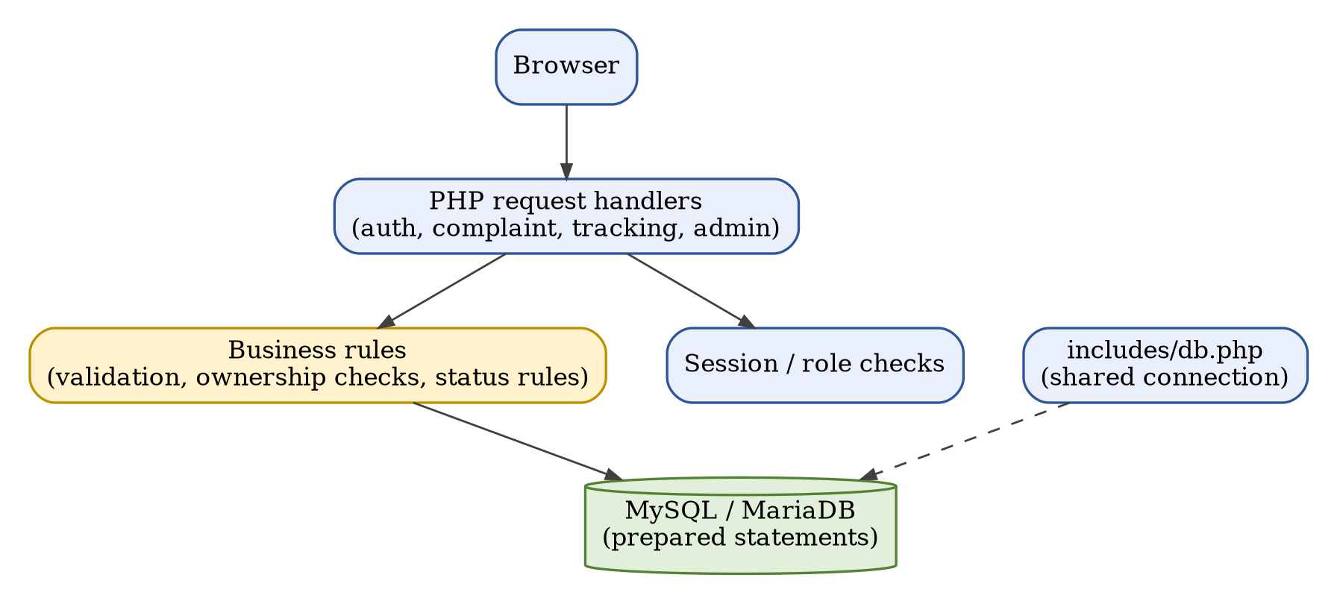
Figure 5.2: Backend Architecture
Table 5.3: Backend Components
Component | Role
includes/db.php | Shared database connection (host, name, user, password, port)
Registration and login handlers | Validate input, hash and verify passwords, manage sessions
Complaint handlers | Validate and save complaints; list own complaints
Admin handlers | Review complaints, update status and remarks
Session / role checks | Allow only the correct role on protected pages

5.3 Database Schema Design
The core database includes students, admins, complaints, complaint_status_history and notifications. The schema uses primary keys, unique constraints, appropriate data types and foreign keys where supported. The tables below are conceptual and must be reconciled with the exact SQL schema imported into the project.
Table 5.4: Conceptual Database Tables
Table | Main Fields | Purpose
students | id, name, email, course, roll number, password hash | Account identity
admins | id, username, password hash | Authorised administrator accounts
complaints | id, student reference, title, details, status, timestamps | Incident details and current status
complaint_status_history | id, complaint reference, old / new status, remarks, timestamp | Record of status changes
notifications | id, student reference, optional complaint reference, message, read state | Student messages

Database relationships and integrity
Relational integrity reduces inconsistent references between student accounts and complaints. Primary keys uniquely identify rows; foreign keys connect complaints to their owners; unique constraints prevent duplicate account identifiers; indexes can improve common lookups by email, status or student ID. Schema changes are backed up and tested before use.
Table 5.5: Relationships Between Tables
Relationship | Cardinality | Meaning
students – complaints | 1 : N | A student can submit many complaints
complaints – complaint_status_history | 1 : N | A complaint can have many status records
students – notifications | 1 : N | A student can receive many notifications
admins – complaint_status_history | 1 : N (where implemented) | An administrator may be recorded against status changes

5.4 Security Considerations
The system handles potentially sensitive allegations and must be designed with privacy in mind. Security requires layered controls, careful operations and human policy – not only a login page.
Table 5.6: Security Controls
Control | Purpose
Password hashing | Never store plaintext credentials
Prepared statements | Protect all queries that use user-supplied values
Output escaping | Prevent user-controlled content from running as HTML or script
Authorisation checks | Enforce student/admin roles on every protected page
Ownership checks | A student sees only their own complaints
Upload validation | Validate type and size; store uploads where scripts cannot execute
Production hardening | HTTPS, strong secrets, backups and least-privilege accounts

Privacy and ethical considerations
- Collect only information needed for the reporting workflow.
- Limit complaint visibility to authorised roles.
- Avoid public demonstration with real student data.
- Define retention and deletion policies.
- Provide a separate escalation route for urgent risks.
MODULE 2
Implementation, Testing, Deployment & Evaluation Phase

6. Application Development
Application development translates the documented requirements into source code. Files have clear responsibilities, shared logic is reused and configuration is not duplicated unnecessarily. The frontend contains the homepage, forms, dashboards and navigation; the backend performs session checks, validation and database operations; the database holds the schema, relationships and persistence. Code excerpts in this report are representative illustrations of the implemented logic.

6.1 Frontend Implementation
The interface includes the homepage, registration and login forms, student dashboard, complaint submission form, complaint list, complaint details and administrator pages. A shared stylesheet supports consistent colours, spacing and responsive behaviour. Semantic headings and labels are associated with fields, required information and accepted formats are explained, and validation errors are shown near the relevant fields. The interface does not claim anonymity or guaranteed response times unless the system supports them.
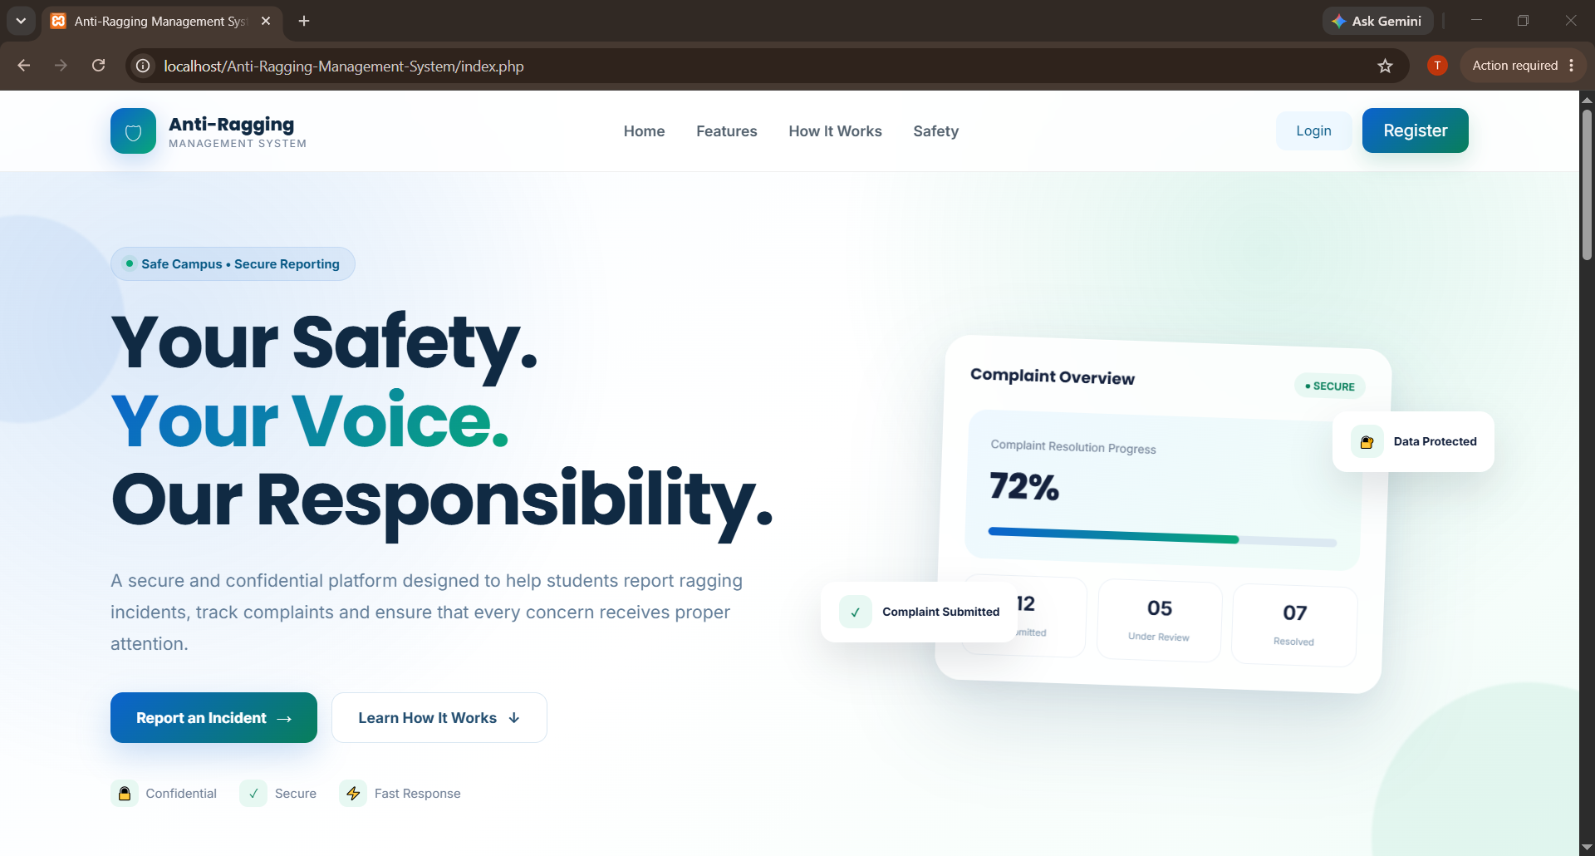
Figure 6.1: Homepage
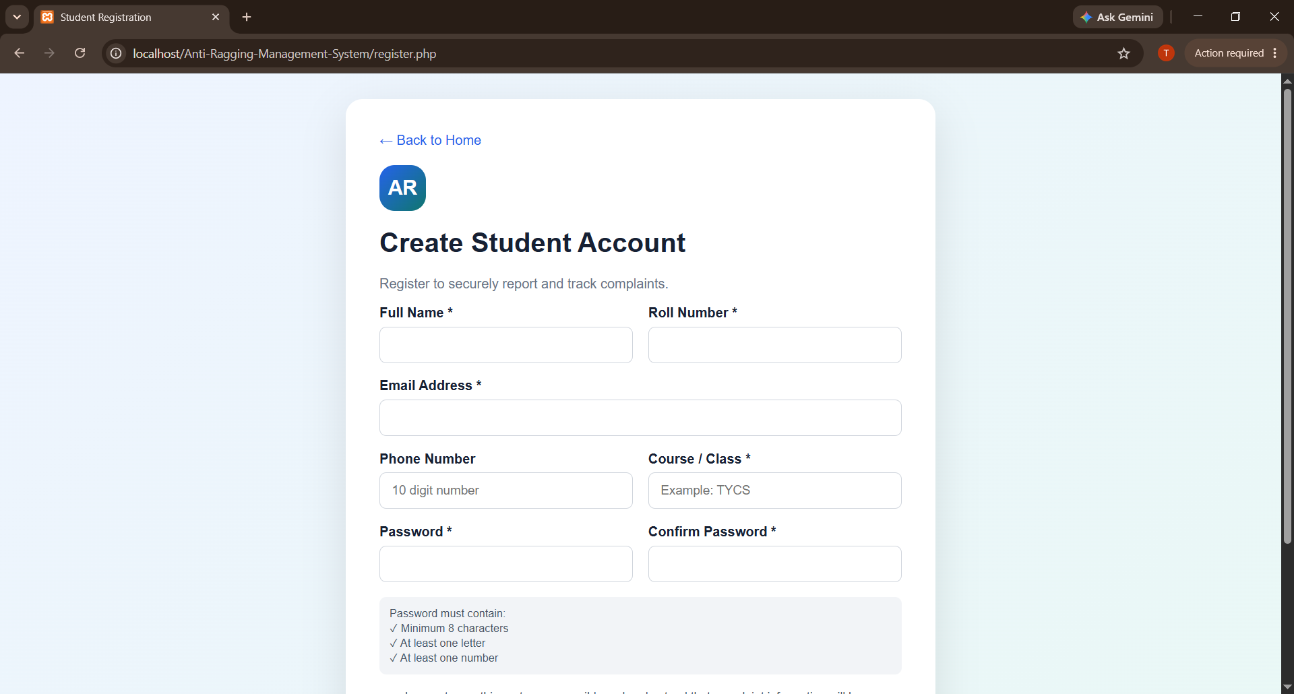
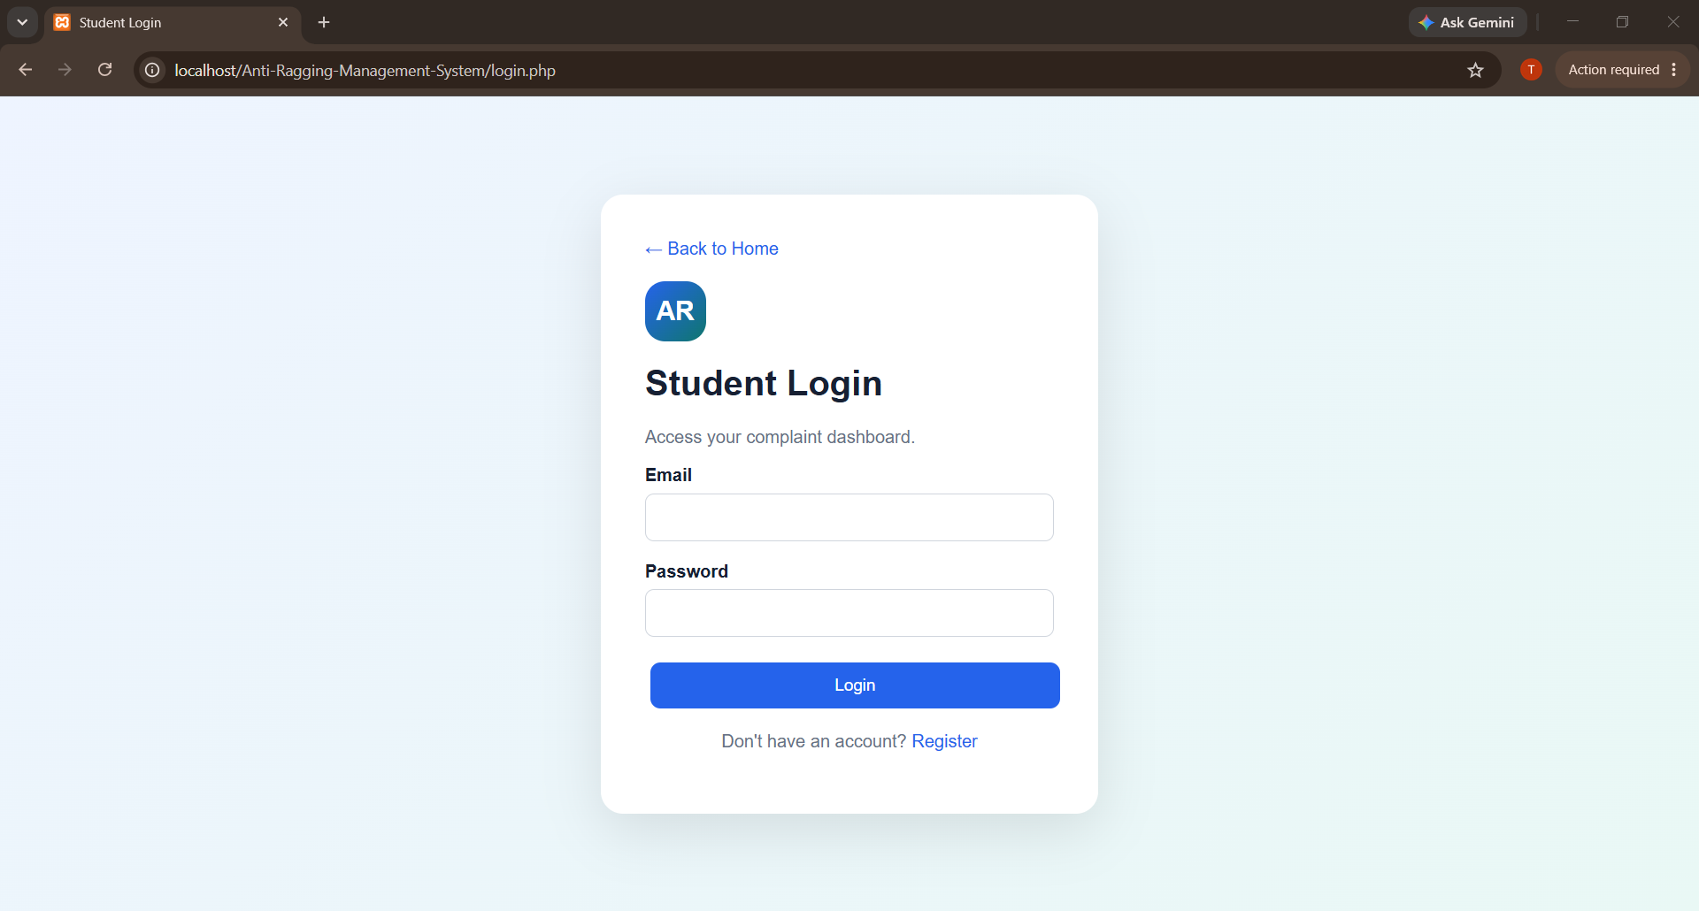
Figure 6.2: Registration and Login Screens
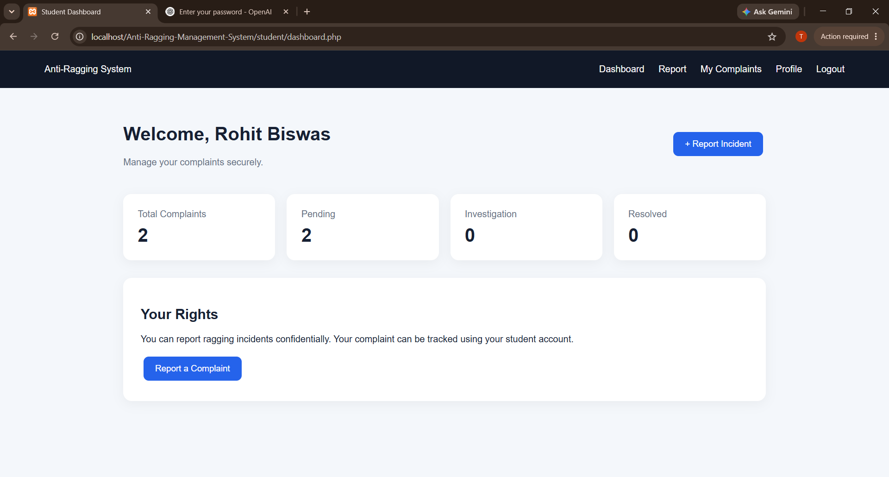
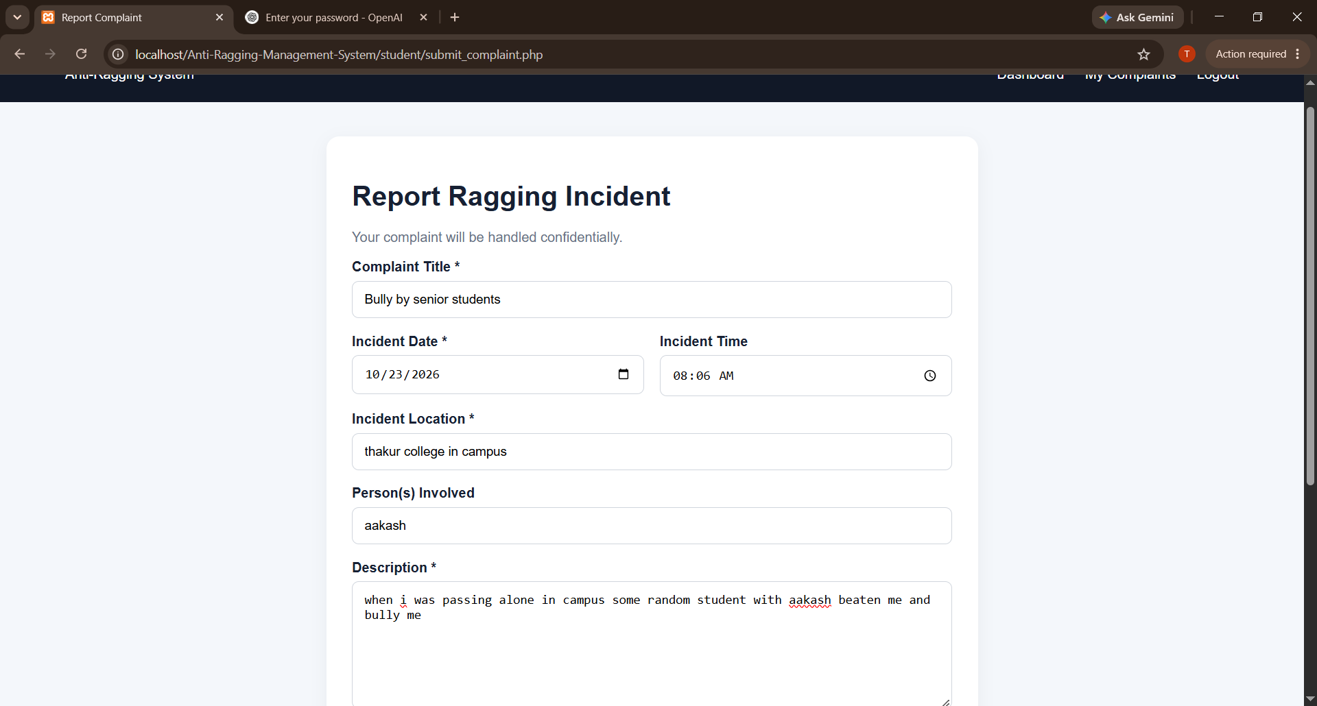
Figure 6.3: Student Dashboard and Complaint Form
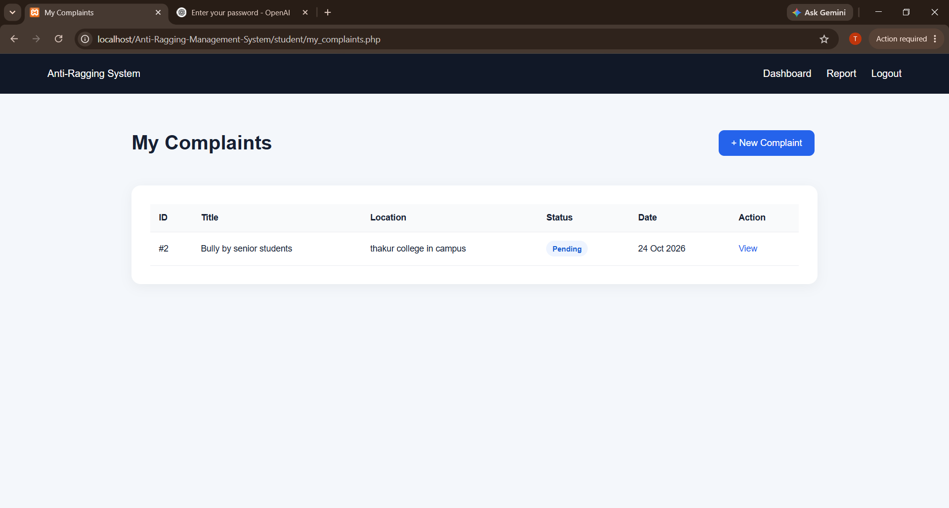
Figure 6.4: My Complaints List
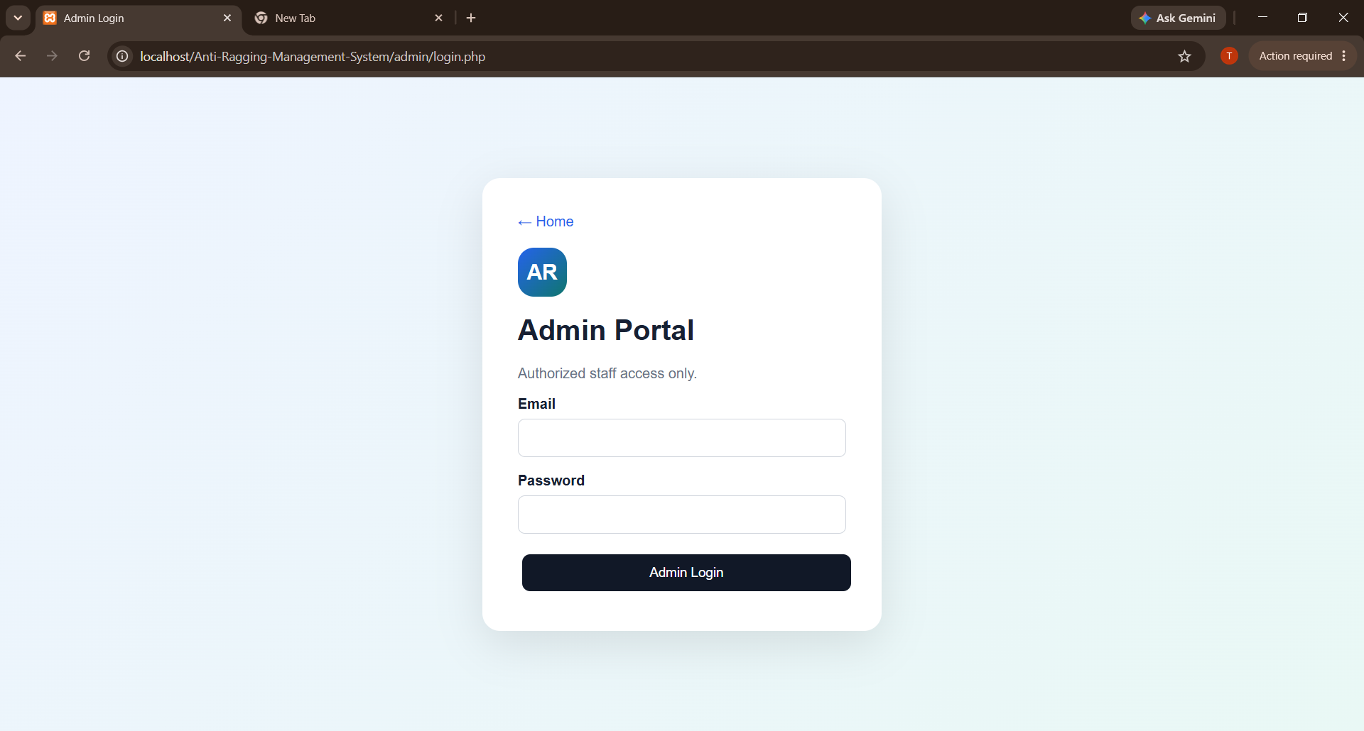
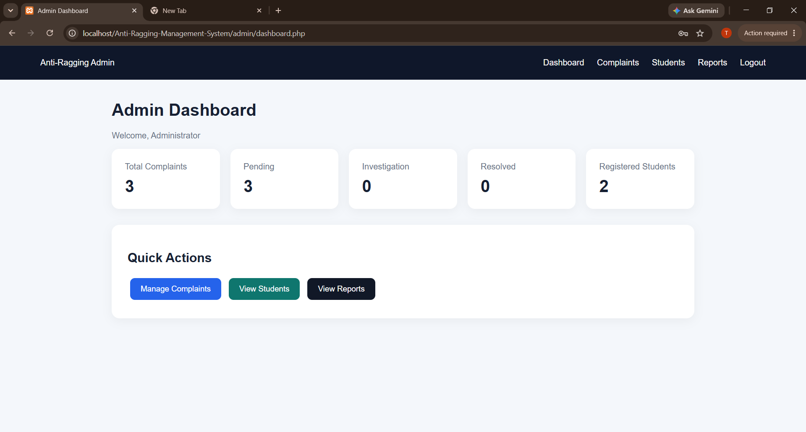
Figure 6.5: Administrator Login and Dashboard
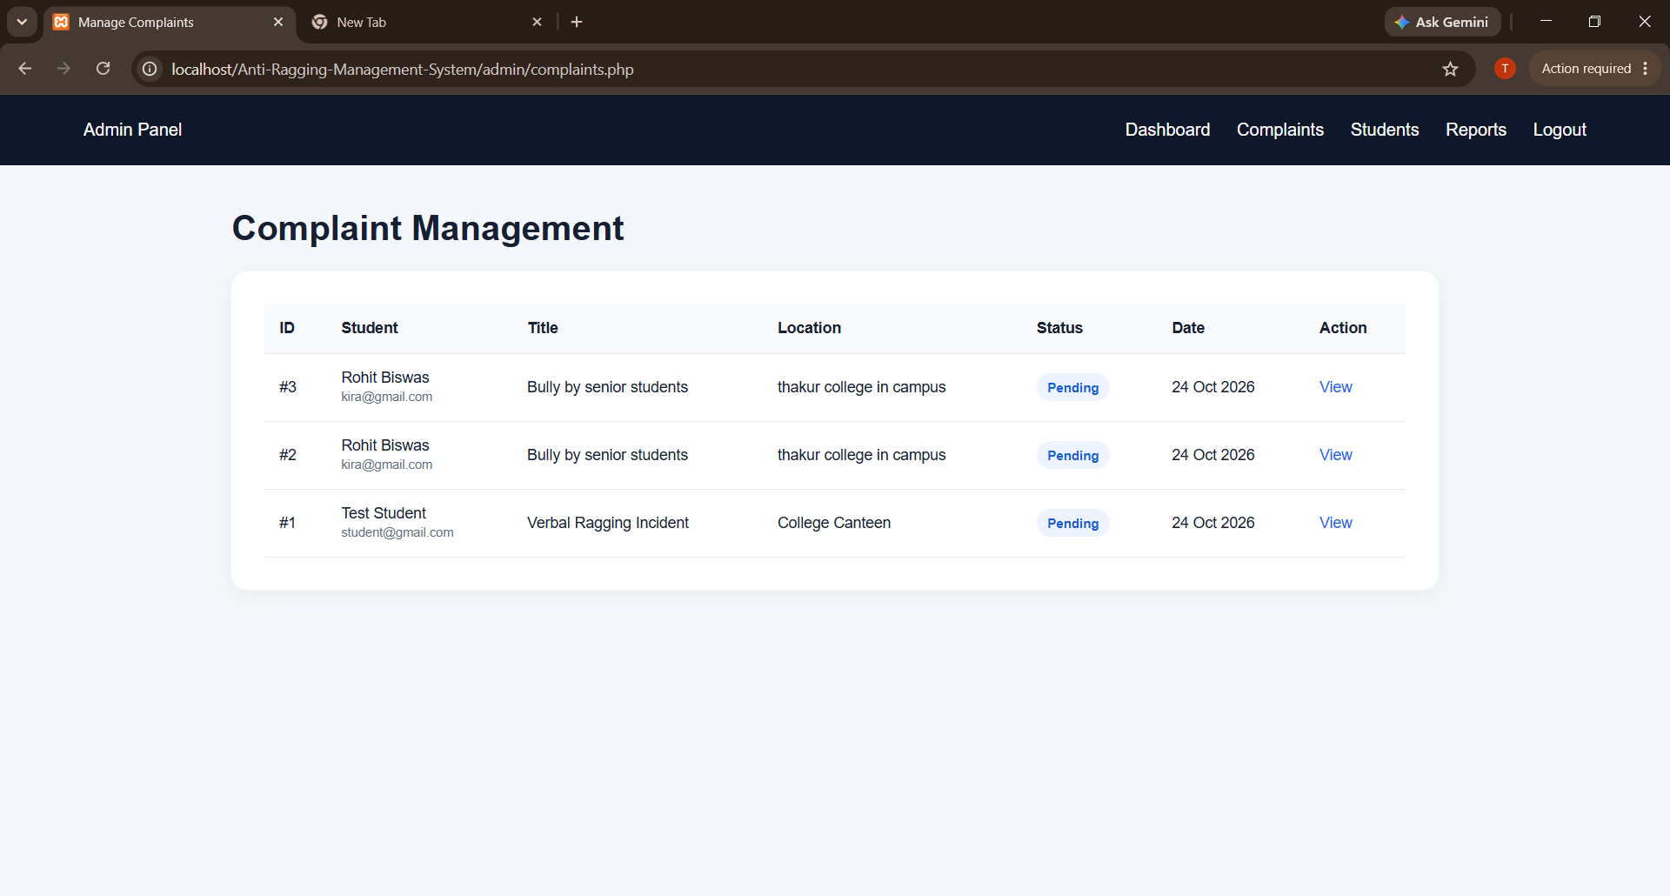
Figure 6.6: Administrator Complaint Management
Table 6.1: Pages, Inputs and Outputs
Page | User Input | Displayed Output
Registration | Name, email, course, roll number, password | Account created or validation message
Login | Email and password | Session started or generic failure message
Complaint form | Title and incident details | Confirmation or validation errors
My Complaints | None | The student’s own complaints with status
Admin dashboard | Status and remarks | Complaint list and update confirmation

6.2 Backend Implementation
The backend processes untrusted browser requests. It checks the session, validates inputs, executes database operations and returns success or failure. It does not trust hidden form fields or user-provided identifiers: the student identifier comes from the session, never from the form.

Representative complaint submission handler
<?php
session_start();
if (!isset($_SESSION["student_id"])) { header("Location: login.php"); exit; }
$studentId = $_SESSION["student_id"]; // never taken from the form
$title = trim($_POST["title"] ?? "");
$details = trim($_POST["details"] ?? "");
if ($title === "" || $details === "") { $errors[] = "Please fill all required fields."; }
$stmt = $conn->prepare("INSERT INTO complaints (student_id, title, details, status)
VALUES (?, ?, ?, 'Pending')");
$stmt->bind_param("iss", $studentId, $title, $details);
if (!$stmt->execute()) { /* controlled error; do not show success */ }

The excerpt shows the key design rules: the session is checked first, required fields are validated on the server, the SQL statement uses parameters and the result of the execution is checked before success is shown. Related records, such as a notification, are inserted in a controlled order and transactions are used where appropriate.
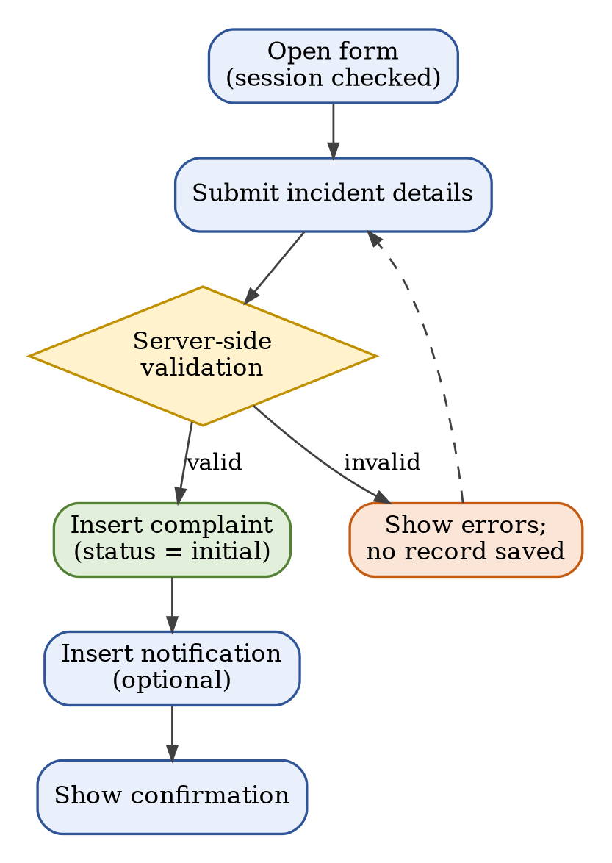
Figure 6.7: Complaint Submission Workflow
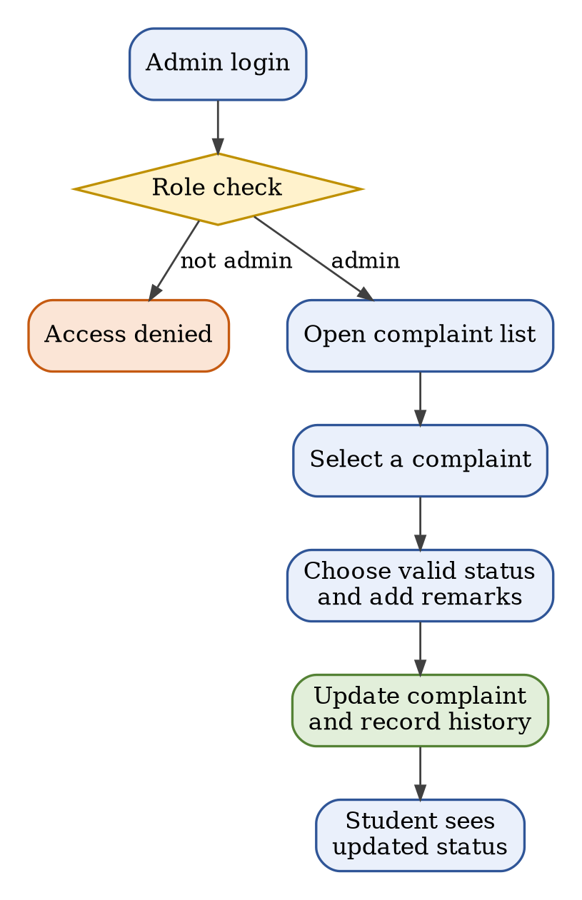
Figure 6.8: Administrator Review Workflow
When an administrator updates a complaint, the new status is validated against the allowed values, saved, and a history record with the remarks and timestamp is created so that the change can be traced. The student sees the updated status in the complaint list.

6.3 Database Integration
The shared connection file specifies the database host, name, username, password and port. The correct port must match the active database service, and a healthy schema is imported before the PHP pages are tested.
- Start Apache and the database service.
- Open phpMyAdmin and select anti_ragging.
- Import the complete SQL schema (anti_ragging.sql).
- Verify the expected tables and foreign keys.
- Match includes/db.php settings to the local service.
- Test a registration and a complaint before adding real data.

Schema creation script (excerpt)
CREATE DATABASE IF NOT EXISTS anti_ragging;
USE anti_ragging;
CREATE TABLE students (
id INT AUTO_INCREMENT PRIMARY KEY,
name VARCHAR(100) NOT NULL,
email VARCHAR(150) NOT NULL UNIQUE,
roll_no VARCHAR(30) NOT NULL UNIQUE,
password VARCHAR(255) NOT NULL
);
CREATE TABLE complaints (
id INT AUTO_INCREMENT PRIMARY KEY,
student_id INT NOT NULL,
title VARCHAR(200) NOT NULL,
details TEXT NOT NULL,
status VARCHAR(30) DEFAULT 'Pending',
FOREIGN KEY (student_id) REFERENCES students(id)
);

The excerpt is representative; the imported SQL file is authoritative. The remaining tables (admins, complaint_status_history and notifications) follow the structures in Chapter 5. A schema-only export without real records is preferred when sharing the project.

6.4 Authentication and Validation
Authentication verifies identity; authorisation controls access. Validation ensures that the submitted data meets the application’s rules. These controls must be enforced on the server.
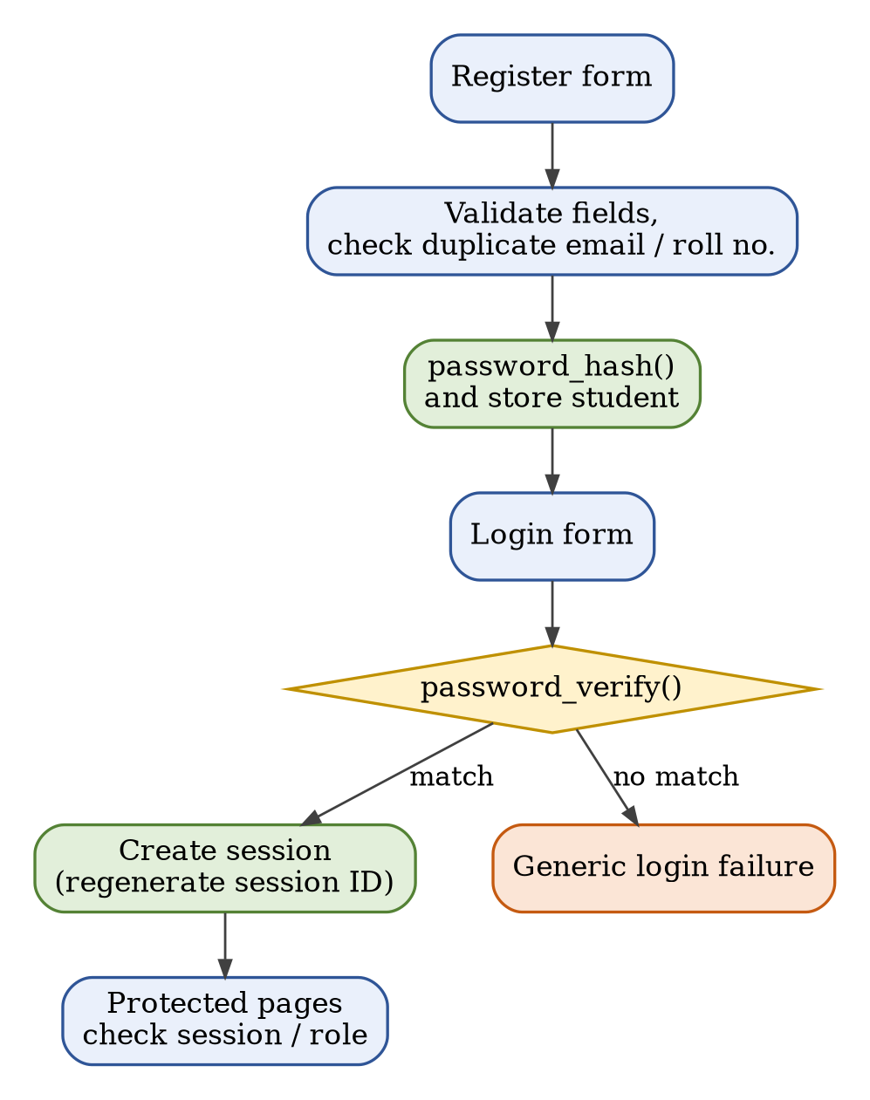
Figure 6.9: Registration and Login Workflow
- Check email format and duplicate account details.
- Use password_hash() when creating accounts and password_verify() during login.
- Regenerate the session ID after a successful login.
- Check the required role on protected pages.
- Validate date, text length, status and uploaded evidence.
Table 6.2: Role-Based Access
Role | Expected Access
Student | Own dashboard, complaint form, own complaint list
Administrator | Admin dashboard, all complaints, status and remarks

6.5 Error Handling
Errors may result from invalid input, failed authentication, database connection problems, constraint violations or file uploads. The application shows understandable messages and keeps technical diagnostics in protected logs. Stack traces are never shown to ordinary users, logs avoid secrets, database writes are checked before success is shown, and backups are kept before destructive schema repairs.
Table 6.3: Error Scenarios and Handling
Scenario | User Response | Developer Action
Missing required field | Message beside the field | Review validation
Wrong password | Generic login failure | Review authentication flow
Duplicate email / roll no. | Registration rejected | Check unique constraints
Database unavailable | Controlled error message | Check service, port and credentials
Unauthorised page | Access denied / redirect | Review role and session checks
Unsupported upload | Upload rejected | Review type and size rules

7. Integration & System Testing
Testing verifies that each component behaves correctly and that connected modules exchange data properly. Actual outcomes are recorded after running the application; unexecuted tests are never marked as passed.
Table 7.1: Testing Strategy
Testing Type | Example
Unit | Email validation, password verification, date and status validation
Black-box | Registration, login, complaint submission through the browser
Integration | Form → PHP → database → status shown to the student
Security | Protected pages while logged out; another student’s record
Regression | Repeat key flows after every change

7.1 Unit Testing
Unit tests check small pieces of functionality such as email validation, password verification, date validation and status validation. These can be performed manually or automated if the logic is separated into testable functions.
Table 7.2: Unit Test Targets
Check | Expected Result
Valid email | Passes format validation
Malformed email | Rejected
Correct password | Verifies against its hash
Incorrect password | Fails verification
Unsupported complaint status | Rejected

7.2 Black-Box Testing
Black-box testing treats the application as a system and checks its visible behaviour without requiring knowledge of the internal code.
Table 7.3: Black-Box Test Scenarios
Action | Expected Result
Register with valid details | Account created
Attempt a duplicate email | Rejected
Log in with wrong credentials | Denied
Submit a complaint with missing fields | Validation message
Open protected pages while logged out | Redirect or denial
Open another student’s complaint | Not visible; access denied

7.3 Integration Testing
Integration testing checks complete workflows across pages and database tables. It is especially important when a single action creates a complaint and a related notification or history record.
- Registration should create a student record.
- Login should establish a valid session.
- Complaint submission should create the complaint row.
- Notification creation should reference the correct student.
- Admin status changes should appear in the student’s view.

7.4 Test Case Preparation
A test case states the purpose, preconditions, steps, expected result and actual result. Test records make the project evaluation reproducible and show what was actually verified. The actual result column is completed only after execution.
Table 7.4: Sample Test Case Matrix
ID | Test | Expected Result | Actual Result
TC-01 | Register valid student | Account is created | To be completed
TC-02 | Duplicate email | Registration rejected | To be completed
TC-03 | Invalid password | Login rejected | To be completed
TC-04 | Submit valid complaint | Complaint saved | To be completed
TC-05 | Missing required field | Validation message | To be completed
TC-06 | Student opens another student’s complaint | Access denied | To be completed
TC-07 | Admin updates status | New status saved | To be completed
TC-08 | Unsupported upload | Upload rejected | To be completed
TC-09 | Logout then open dashboard | Redirect / denial | To be completed
TC-10 | Database unavailable | Controlled error message | To be completed

7.5 Bug Tracking
A bug record includes a short title, environment, reproduction steps, expected and actual behaviour, severity, fix and retest result. Database credentials and private student data are kept out of screenshots shared for debugging.
Table 7.5: Bug Log Template
Bug | Severity | Example | Action
BUG-01 | Critical | Access to another student’s complaint | Fix before release
BUG-02 | Major | Complaint save fails | Investigate and retest
BUG-03 | Major | Incorrect database port | Correct the configuration
BUG-04 | Minor | Spacing inconsistency | Fix if time permits

- Record the exact error text and file/line number.
- Capture relevant logs with secrets removed.
- Fix the root cause rather than hiding the error.
- Retest the affected workflow and nearby features.
- Update the documentation when behaviour changes.

8. Application Deployment
Deployment makes the application available in a target environment. Local XAMPP hosting is suitable for development. Public deployment requires stronger configuration, HTTPS, backup and operational controls.

8.1 Cloud Deployment
A PHP/MySQL project can be hosted on a compatible server. Before deployment, the PHP version, database support, file permissions, HTTPS, environment configuration and backup procedures are confirmed. A development database or development credentials are never exposed publicly.
Table 8.1: Cloud Deployment Checklist
Item | Recommendation
Hosting | A host that supports the required PHP runtime
Database | Create a database and a least-privilege database user
Configuration | Import the schema and configure production credentials securely
HTTPS and logs | Enable HTTPS and protected error logging
Release check | Test access control and backups before public release

8.2 Local Hosting
For local testing, the project folder is placed inside the XAMPP htdocs directory. Apache and the database service are started, the SQL schema is imported and the project is opened using localhost rather than a file path.
Project path : C:\xampp\htdocs\Anti-Ragging-Management-System
phpMyAdmin : http://localhost/phpmyadmin
Database : anti_ragging (import anti_ragging.sql)
Application : http://localhost/Anti-Ragging-Management-System/

- Start Apache and the database service.
- Import the anti_ragging.sql schema.
- Check the actual database port and connection settings.
- Open the application URL.
- Test registration, complaint submission and admin status updates.

8.3 APK Build
The delivered project is a PHP web application. PHP pages are served by a web server and do not directly compile into an Android APK. A native mobile app would require a separate client and a backend API, or a carefully designed WebView wrapper. APK development is therefore treated as a future enhancement unless implemented.
- A mobile client needs secure API endpoints.
- Use HTTPS for remote communication.
- Apply authentication and authorisation to every API operation.
- Test mobile navigation, upload behaviour and session expiry.

8.4 Server Configuration
Server configuration controls how the web server and database operate. Incorrect ports, credentials, file permissions or PHP settings can prevent the application from working.
- Confirm the active database port before editing db.php.
- Use a strong database password and a restricted database account.
- Disable public display of detailed errors in production.
- Limit upload size and allowed file types.
- Protect configuration files and uploaded evidence.
- Use HTTPS for remote access and maintain backups.

Maintenance plan
- Correct bugs discovered during testing.
- Keep PHP and database software supported and updated.
- Review access permissions periodically.
- Back up the database and test restoration.
- Update documentation after schema or code changes.
- Review privacy controls before production deployment.

8.5 Version Control Using GitHub
Git tracks source changes and helps restore a stable version. The repository includes source code, the SQL schema without real personal records, README instructions and a .gitignore file.
git init
git add .
git commit -m "Initial Anti-Ragging Management System commit"
git branch -M main
git remote add origin <repository-url>
git push -u origin main

Table 8.2: What to Share and What Not to Share
Safe to Share | Do Not Share
Source code and templates | Passwords and configuration with credentials
Schema-only SQL file | Real complaint evidence or database exports
README and documentation | Logs and uploaded files

- Commit a stable baseline before major changes.
- Use descriptive commit messages.
- Rotate credentials if a secret is accidentally committed.

9. Performance & Security Testing
Performance testing examines response time and resource usage. Security testing checks whether the application protects accounts and complaint records against common web risks.

9.1 Basic Load Testing
A basic load test measures how the application responds to repeated requests. The report records actual observations rather than invented performance figures. The hardware, PHP version and database version are recorded; the homepage, login and complaint-list response times are measured; a test complaint is submitted and its persistence verified. The tests are repeated and an average or median is calculated. A live service is never load-tested without permission.
Table 9.1: Load Test Result Template
Operation | Users | Avg. Time | Errors | Notes
Homepage | 1
Login | 1
Complaint list | 10
Submit complaint | 1

9.2 Input Validation Checks
Validation rejects malformed or unsafe data at the server. Client-side checks help usability but can be bypassed and are not the only defence.
Table 9.2: Input Validation Checks
Check | Expected Handling
Required fields and maximum lengths | Rejected with a message
Email format and unique fields | Rejected when invalid or duplicate
Dates | Parsed using the expected format
Complaint status | Only defined values accepted
Uploaded files | Size, type and generated file name validated
User-controlled output | Escaped in HTML

9.3 Security Validation
Complaint records can contain sensitive information, so the application minimises collection and restricts access. The project is reviewed for common web application risks before any real use.
Table 9.3: Security Validation Checklist
Risk | Check
SQL injection | Use prepared statements
Cross-site scripting | Escape output in the correct context
Broken access control | Verify record ownership on every request
Session management | Check logout and protected pages
Password storage | Verify that only hashes are stored
File uploads | Reject unsupported files and prevent execution
Privacy | Define access, retention, escalation and deletion rules

10. Final Documentation
Final documentation explains the system, user workflows, testing, limitations and future work. The report matches the delivered source code and database schema.

10.1 Report Generation
The black book is organised into two modules following the supplied index. It includes the problem statement, feasibility, requirements, SDLC plan, UML models, architecture, implementation, testing, deployment, security and appendices. Consistent headings and page numbers are used, genuine screenshots of the completed application are added, placeholders are replaced with the actual guide and institution details, real test outcomes are recorded and any inaccurate claim is corrected.
Table 10.1: Requirement Traceability
Req. | Design Element | Test
FR-01, FR-02 | Use case: Register; ER: students | TC-01, TC-02
FR-03 | Use case: Login | TC-03, TC-09
FR-04, FR-05 | Activity and sequence diagrams | TC-04, TC-05
FR-06 | Ownership checks | TC-06
FR-07, FR-08 | Admin use cases | TC-07
FR-09 | ER: complaint_status_history | Integration test
FR-10 | Reports | Manual check

10.2 User Manual
Students register, log in, submit a complaint and use the complaint list to view status. Administrators authenticate, review cases and update status according to institutional procedures. Detailed manuals are given in Appendix A and Appendix B.
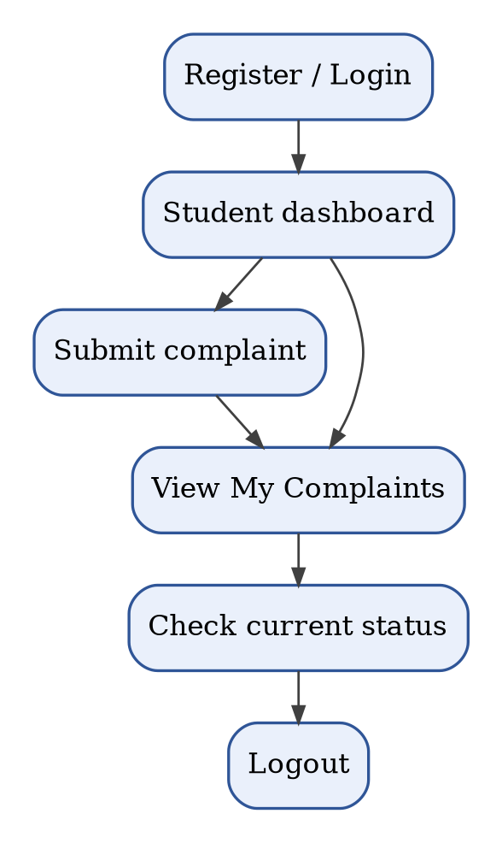
Figure 10.1: Student Workflow
- Use accurate details when completing forms.
- Do not share passwords or use shared accounts.
- Log out after using a shared computer.
- Administrators access only the records needed for their role.
- Follow institutional procedures for urgent safety concerns.

10.3 Limitations
- The system does not independently verify allegations.
- Confidentiality depends on configuration and operational practice.
- Notifications may be limited to in-app records.
- Production hosting and HTTPS require separate setup.
- Reports may offer only basic counts and status summaries.
- Human review and institutional policy remain essential.
- The current implementation is a web application; there is no APK.

10.4 Future Enhancements
Table 10.2: Future Enhancements
Enhancement | Benefit
Multi-factor authentication for administrators | Stronger account security
Secure email notifications and escalation reminders | Timely communication
Accessible, multilingual interface | Wider reach
Audit logs for sensitive administrative actions | Accountability
Encrypted backups and retention controls | Data protection
Role-based case assignment to an authorised committee | Clear responsibility
Aggregated reports without personal information | Safer analytics

10.5 References
The following official learning resources are relevant to the technologies and secure-development practices used in the project.
- PHP Manual. https://www.php.net/manual/en/
- MySQL Reference Manual. https://dev.mysql.com/doc/
- MDN Web Docs. https://developer.mozilla.org/
- OWASP Cheat Sheet Series. https://cheatsheetseries.owasp.org/
- XAMPP Project. https://www.apachefriends.org/
- Git Documentation. https://git-scm.com/doc/

Conclusion
The Anti-Ragging Management System demonstrates how a web application can organise complaint submission and administrative review. The project combines a browser-based interface with PHP processing and relational database storage. Students can submit incident details and track their own records, and authorised administrators can review complaints and update status.
The project documents requirements, architecture and workflows and applies core web development and database concepts. Testing should be completed with actual test data and recorded results. Security, privacy and institutional governance are essential for real use, and future work may add stronger authentication, notifications and audit logs.

Appendix A: Student User Manual
This section describes the expected student workflow. Exact button labels may vary with the final user interface.
- Register: open Register, complete the required details and submit.
- Login: enter the registered credentials; do not share them.
- Submit complaint: provide the incident details and review them before submission.
- Track: open My Complaints to view the current status.
- Logout: end the session after use, especially on shared computers.

Appendix B: Administrator User Manual
This section describes the workflow for authorised administrators.
- Use credentials provisioned through an approved setup process.
- Open the complaint list and select a record for review.
- Follow institutional procedures when examining a complaint.
- Choose a valid status and add factual remarks when appropriate.
- Verify the saved status and log out after use.
- Do not leave temporary admin-creation scripts accessible.
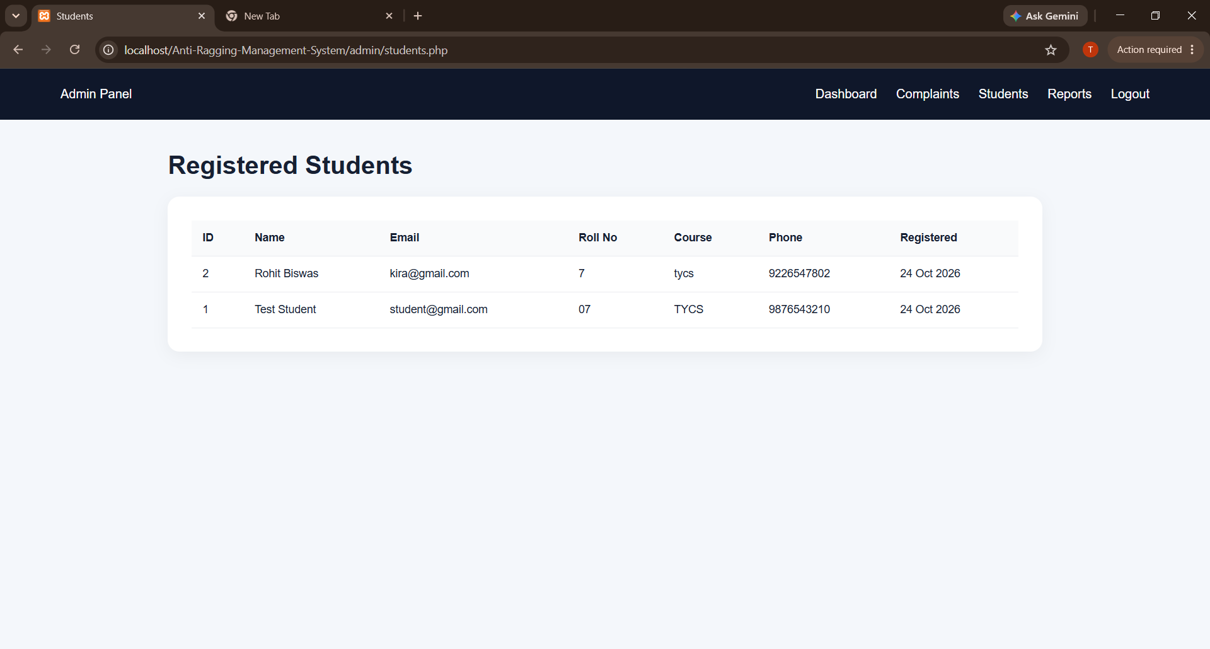
Figure B.1: Registered Students (Administrator View)
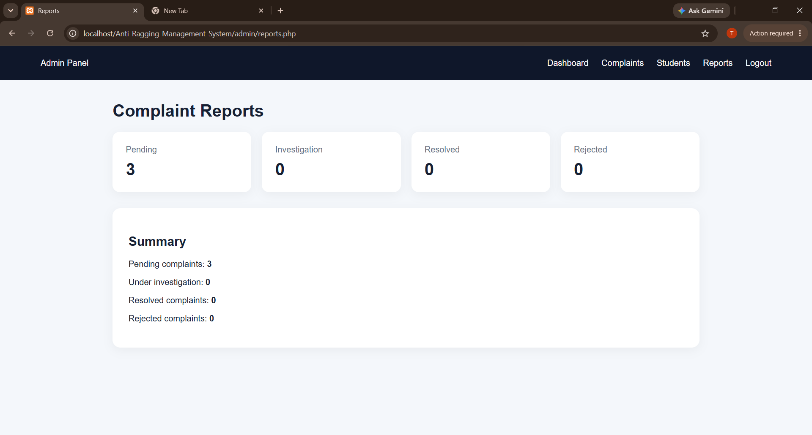
Figure B.2: Complaint Reports Summary (Administrator View)

Appendix C: Database Data Dictionary
The following descriptions are conceptual and must be reconciled with the exact SQL schema imported into the project.
Table C.1: Data Dictionary
Table | Description
students | Account identity, course, roll number and password hash
admins | Authorised administrator accounts and password hashes
complaints | Incident details, owner, status, remarks and timestamps
complaint_status_history | Old/new status, remarks and change timestamp
notifications | Student message, optional complaint reference and read state

Appendix D: Acceptance Checklist
Use this checklist during the final review. Mark items only after checking the running application.
Table D.1: Acceptance Checklist
Item | Done
Apache and the database services start successfully
SQL schema imports without errors
Registration, duplicate checking, login and logout work
Complaint submission persists and can be viewed by its owner
Admin can update status and the student can see the update
Protected pages reject unauthorised users
Validation, prepared statements and output encoding are reviewed
Documentation matches the actual code and SQL schema
Genuine screenshots inserted; test results and guide / institution details completed

Appendix E: Glossary
Table E.1: Glossary of Terms
Term | Meaning
Authentication | Verification of user identity
Authorisation | Rules defining which actions a user may perform
Backend | Server-side request processing and business rules
Database | Organised collection of persistent records
Foreign key | Constraint linking records across tables
Prepared statement | Parameterised query separating SQL from values
Session | Server-managed state for an authenticated user
SDLC | Software Development Life Cycle
UML | Unified Modeling Language

